**Chapter 1**

**Introduction**

**Introduction:**

* **Organization/Client Name :** Dr. Dilip Kashiwar

(B.V.Sc & A.H , M.V.Sc(Medicine) )

* **Location & Address :** Ganesh Park, Near Vidhya Sahakari Bank,

Wadgaon Phata Sinhgad Road, Wadgaon

(BK) PUNE-411041

* **E-mail :**
* **Contact No :** +91-9763679787
* **Timing :** 10 AM-To-2 PM, 5 PM-To-9 PM

SUNDAY (10 AM-To-2 PM)

* 1. **Organization/Client Profile:**
* **About Organization:**
* The Pet Care Center is Established in Year 2018 the location of Pet care center in Pune, on Sinhgad road Near by Fun time Mall.
* Pet Care Center Will Provide all types of food for dog and cat as well as accessories and we have specialist for dog trainer.
* Will provide pet care accessories & Dresses as well as shampoo, soap, oil and nutrition.
* Purva pet care center is providing all types of groceries for dog and cat and other animal.
* Also, will provide medicine & vaccination form authorized Doctors.
* Will provide pet dresses and bead and blankets and cages.
* Purva Pet Care Center one of the best pet doctors in city. This Care Center takes complete care of pets and their foods Accessories.
* But these all service are provided offline that’s why they want online service for customer that’s why will create website for user require- ments
  1. **Abstract:**

We are building a website in a way that we create a login for all users. After logging in, the user is directed towards the homepage where he/she could see the pets Food available for buying. Besides these, one could see options for buying accessories and managing his/her account. The details of the pet’s food, some of its pictures, it's price etc. buyer can view pet food categories and can contact the seller. Moreover, we are also providing a feature that allows the users to know about all the pet shops in the nearby location so that they could buy pet accessories or its food.

Customer will get product detail: customer who can access our website

using login and password they can buy food and pet accessories form

website directly.

Customer can login and logout service: if any customer wants any type of

accessories for cat they have to have login credentials like user ID and Password.

Admin Can control All Data: in our website there is admin page is available

And Admin can control all data and create multiple account of user and delete their account and access their detail for future communication.

Report Generate: Also, admin can control data base like stock & income or check stock by monthly and generate report of monthly.

Admin have login and log out service: Even admin have to have login

credential with out login or password admin cannot access data base

All types of food are available: there are many types of categories are in pet

Like puppies, adults and over age animal are there, so will provide all types of food for all animals

* 1. **Existing System & Need for System:**
* **Existing System:**

Existing system refer old manually paper work system followed till now the other disadvantage of existing system are lack of security of data, deficiency of data accurately the system needs to be computerized. Manually report cannot be generated. Hence, there is a need of reformation of the system with more advantages and flexibility.

Inconsistency in data: now the system is manual mode that why there is no

consistency in data of cash or product detail and report.

Lack of security: as we see in above existing system there is no proper record

Keeping like heath card and and their medical detail.

Manually data keeping: if we think about offline keeping record there is som draw bag like data missing so reduce such as draw bag.

* **Need For System:**

This is a web-based project that is developed to help users for Buying Food. And will keep record and pet related activities in a secure manner. The concept of this Pet care center customer can buy pets food and Accessories.

To avoid these limitations there is a need of developing the web-based system which should be user friendly, easy to maintain and store the related information or data, easy to retrieve the stored data, helps in making fast decisions and the whole process should become faster than the existing manual system. Our software has the facility to give a unique id and stores every pet’s food details

* 1. **Scope of System:**
* This is a Web-site that is developed to help users for buying pets Food or accessories, it will record pet related activities in a secure manner. The concept of this pet clinic center is to sell food as well as accessary.
* Allowing administrator do all the maintenance in the system, allowing all user to register and visit our website, and use our basic function to reduce the workload of the user such food module
* Modules of Pet Clinic Center
* Food:

Customer can buy fresh food for their pet there are multiple types of food are available in our website also customer can view a product using login credentials.

* Accessary: Also, customer can buy multiple types of accessories like belt dog and cat dress bed and some groceries and many more, even customer can buy medicine for their pets.
* Suppliers: in web site we separately created this module because of admin have to know the stock of food and medicine for generating report or record for future analysis and taking good future decision and increasing sell.
* Customer: in customer model first of all we will provide a registration form to every customer and they got login and password. Using login credentials customer can visit product and buy product like food, accessories and groceries and buy them.
  1. **Operating Environment:**
* **Client-side Requirement:**
* Processor (CPU) : Intel®, Celeron®, CPU N3060®,

1.6GHz.

* Primary Memory (RAM) : 4.00 GB.
* Hard Disk Drive : 1 TB.
* Input device : Keyboard, Mouse.
* Output Device : Monitor Screen.
* Browser : Latest Updated Browser.
* **Server-side Requirement:**
* Database : XAMP Server (7.4.29v)

MYSQL (8.0.29).

* Processor : Intel Core I3.
* RAM : 4GB.
* Hard Disk : 500GB.
* Language : PHP (3.3.0.v)
* **Development-Side environment:**
* Client Side : HTML5, CSS3, JavaScript,
* Sever Side Language : PHP (3.3.0.v)
* Data Base Server : XAMP.
* Operating System : Windows 10.
* Editors : Visual Code.
* Browser : Latest upgraded any browser like

MS-Edge, Chrome.

* 1. **Brief Description of Technology Used:**

**1.6.1 Operating Systems used (Windows or Linux):**

**Windows:**

Windows Stands for Wide Interactive Network Development for Office Work Solution. Windows is one of the most common operating systems that run on personal computers, tablets, and smartphones.

Microsoft introduced an operating system named Windows on November 20. Microsoft Windows, also known as Windows and Windows Operating System developed by Microsoft Corporation to run personal computers (PCs). Microsoft choose "Windows" because multiple windows that allow different tasks and programs that run at the same time.

Windows 11 is the latest major released version of Microsoft’s Windows NT operating system, released in 2021. It is free upgrade to its previous version, Windows (2015), available for new Windows 10 devices that meets to new requirements of Windows 11 system.

**1.6.2 RDBMS/No-SQL used to build database (MySQL).**

**JavaScript:**

JavaScript is used by programmers throughout the world to create various dynamic and interactive web content like browsers and applications. Javascript is the most popular programming language in the world, used by client side programming language by all of the websites. Javascript is used to make the web pages dynamic. Before javascript, web pages were build using HTML and CSS. A JavaScript engine which is a software component that is used to execute the JavaScript code.

JavaScript is very easy to execute because it is used within HTML tag. It s an open and cross-platform. Once we learn javascript, it helps us to develop great front-end and back-end softwares using different javascript based frameworks like Node.JS, JQuery, etc. Javascript is executed everywhere, it can be executed on every web browser so we really don’t need any environment setup. For example- Chrome, Safari and Mozilla Firefox and every browser we know today supports Javascript.

**Cascading Style Sheets (CSS):**

CSS (Cascading Style Sheets) is a style sheet used for designing and presenting of a text document written in a markup language such as HTML.CSS is a language used in web design to apply styles to web pages. CSS can be used to edit the styles of multiple web pages.  CSS was designed by World Wide Web Consortium, and also supported by various well known [web browsers](https://simple.wikipedia.org/wiki/Web_browser).

[CSS](https://www.w3.org/Style/CSS/) is the language for designing of Web pages, including various colours, layout, and fonts. CSS has a simple [syntax](https://en.wikipedia.org/wiki/Syntax) and uses a number of keywords to specify the names of various style properties. A style sheet contains a list of rules. Each rule has many [selectors](https://en.wikipedia.org/wiki/CSS#Selector), and a [declaration block](https://en.wikipedia.org/wiki/CSS#Declaration_block).

**HTML:**

The Hyper Text Markup Language or HTML is the standard [markup language](https://en.wikipedia.org/wiki/Markup_language) for documents designed to be displayed in a [web browser](https://en.wikipedia.org/wiki/Web_browser). It uses the technologies such as [Cascading Style Sheets](https://en.wikipedia.org/wiki/Cascading_Style_Sheets) (CSS) and [scripting languages](https://en.wikipedia.org/wiki/Scripting_language) such as [JavaScript](https://en.wikipedia.org/wiki/JavaScript).

 HTML describes the structure of a [web page](https://en.wikipedia.org/wiki/Web_page). With HTML we can construct various images and many images and other object such as interactive forms which may be embedded into the web pages. HTML provides a mean to create [structured documents](https://en.wikipedia.org/wiki/Structured_document) by using structural [semantics](https://en.wikipedia.org/wiki/Semantics) for text such as headings, paragraphs, lists, [links](https://en.wikipedia.org/wiki/Hyperlink) and other items. HTML elements uses many different tags, written in [angle brackets](https://en.wikipedia.org/wiki/Bracket#Angle_brackets). Tags such as <img> and <input> directly introduce content into the page. Other tags such as <p> needs to provide information about text document and includes other tags as sub-elements. Browsers don’t display the HTML tags but uses the HTML element to display various different type of contents.

**MySQL:**

MySQL is a relational database management system based on the Structured Query Language(SQL), which is the most popular language for retrieve and managing the records in the database. MySQL is open-source and free software. It is supported by **Oracle Company.**

MySQL support many queries like insert records, update records, delete records, select records, create tables, drop tables, etc. MySQL is one of the best RDBMS which is used for developing web-based software applications. MySQL is written in C and C++ language. MySQL is most commonly-used database used at backend in the software.

**PHP:**

PHP is an open-source server-side scripting language that many devs use for web development. It is also a general-purpose language that you can use to make lots of projects, including Graphical User Interfaces (GUIs).

In this article, I will help you explore the world of PHP so you can learn how it works and its basic features. By the end, you will be able to write your first Hello World program in PHP.

* What Does PHP Mean?

The abbreviation PHP initially stood for Personal Homepage. But now it is a recursive acronym for Hypertext Preprocessor. (It's recursive in the sense that the first word itself is an abbreviation, so the full meaning doesn't follow the abbreviation.)

The first version of PHP was launched 26 years ago. Now it's on version 8, released in November 2020, but version 7 remains the most widely used.

PHP runs on the Zend engine, which is the most popular implementation. There are some other implementations as well, like parrot, HPVM (Hip Hop Virtual Machine), and Hip Hop, created by Facebook.

PHP is mostly used for making web servers. It runs on the browser and is also capable of running in the command line. So, if you don't feel like showing your code output in the browser, you can show it in the terminal.

* Advantages of PHP

PHP has some advantages that have made it so popular, and it's been the go-to language for web servers for more than 15 years now. Here are some of PHP's benefits:

Cross-Platform: PHP is platform-independent. You don't have to have a particular OS to use it because it runs on every platform, whether it's Mac, Windows, or Linux.

Open Source: PHP is open source. The original code is made available to everyone who wants to build upon it. This is one of the reasons why one of its frameworks, Laravel, is so popular.

Easy to learn: PHP is not hard to learn for absolute beginners. You can pick it up pretty if you already have programming knowledge.

PHP syncs with all Databases: You can easily connect PHP to all Databases, relational and non-relational. So it can connect in no time to MySQL, Postgress, MongoDB, or any other database.

Supportive Community: PHP has a very supportive online community. The official documentation provides guides on how to use the features and you can easily get your problem fixed while stuck.

**Chapter 2**

**Proposed System**

* 1. **Proposed System:**

The aim of proposed system is to develop a system of improved facilities. The proposed system can overcome all the limitations of the existing system. The system provides proper security and reduce the manual work. The existing system has several disadvantages and many more difficulties to work well. The proposed system tried to eliminate or reduce these difficulties up to some extent. The proposed system will help the user to reduce the workload and mental conflict. The proposed system helps the user to work user friendly and he can so his job without time lagging

**Advantages of proposed system:**

The system is very simple in design and implement. The system required very low system resource and the system will in almost all configuration.it has got following feature.

* Ensure data accuracy.
* Minimize manually data entry.
* Minimize time needed for the various processing.
* Greater efficiency.
* Minimize time required.
* This would help the corporate prepare and organize its schedules more efficiently on the basis of traffic demand.
* It would provide data on concession given to various section.

This Website is to computerized the current system. To change the current full manual system to a more completed automated system. By using computerized system, human error such as file missing will be reducing. The information will be more accurate when human mistake is reduced.

**Enhancement:** The main objective of Pet Care center is to enhance and upgrade the existing system by increasing its efficiency and effectiveness. The web improves the working methods by replacing the existing manual system with the wed-based system.

**Automation:** The pet care center automates each and every activity of the manual system and increases its throughput. Thus, the response time of the system is very less and it works very fast.

**Accuracy:** The pet care center provides the uses a quick response with very accurate information regarding the users etc. Any details or system in an accurate manner, as and when required.

**User-Friendly:** The web-site pet care center has a very user-friendly interface. Thus, the users will feel very easy to work on it. The we-site provides accuracy along with a pleasant interface. Make the present manual system more interactive, speedy and user friendly.

**Availability:** The transaction reports of the system can be retried as and when required. Thus, there is no delay in the availability of any information, whatever needed, can be captured very quickly and easily.

**Maintenance Cost:** Reduce the cost of maintenance.

**Security:** This is very important aspect of the design and should cover areas of database reliability, fall back procedures, physical security of data and provision for detection of fraud and abuse. System design involves first logical design and then physical construction of the system. The logical design describes the structure and characteristics of features, like the outputs, inputs, files, database and procedures. The physical construction, which follows the logical design,

* 1. **Feasibility Study:**

Feasibility study is a process that identifies, describes and evaluates proposed

system and selects the best system. During the study, the problem definition is

solved and all aspects of problem to be included in the system are determined.

Size of project, cost of benefits is also estimated with greater accuracy. A good

feasibility study will show the strength and defects before the project is planned

or budgeted.

**2.2.1 Technical Feasibility:**

Technical Feasibility deals with the hardware as well as software requires requirements. Technology is not a constraint to type system development We have to find out whether the necessary technology, the proposed equipment’s have the capacity to hold the data, which is used in the project, should be checked to carry out this technical feasibility.

The technical feasibility issues usually raised during the feasibility stage of investigation includes these

* This software is running in windows 2000 Operating System, which can be easily installed.
* The hardware required is Pentium based server.
* The system can be expanded.

It determines whether the technology is needed for the proposed system is avail-able and how it can be integrated with the government. Technical evaluation must assess whether the user have technical expert to understand and use the new system. This assessment is based on an outline design of system requirements, to determine whether proposal is technically and legally feasible. It is the evaluation of the hardware and software and how it meets the need of the proposed system. The technology used can be developed with the current equipment's and has the technical capacity to hold data required by the old system.

**2.2.2 Economic Feasibility:**

Economic Feasibility deals about the economic impact faced by the organization to implement a new system. Financial benefits must equal or exceed the costs. The cost of conducting a full system, including software and hardware cost for the class of application being considered should be evaluated. Economic Feasibility in this project:

• The cost to conduct a full system investigation is possible.

• There is no additional manpower requirement.

• There is no additional cost involved in maintaining the proposed system.

The purpose of the economic feasibility assessment is to determine the positive economic benefits to the organization that the proposed system will provide. It includes quantification and identification. It identifies the financial benefits and cost associated with the development of the system. Economic feasibility is often known as the cost benefits analysis. To carry out an economic feasibility study it is necessary to estimate actual money value against activities needed for implementing the system. While implementing our system we can ensure that the cost of prospective new venture will ultimately be profitable to the people. So, we can say it is financially feasible.

* + The cost to conduct a full system investigation is possible.
  + There is no additional manpower requirement.
  + There is no additional cost involved in maintaining the proposed system.

* + 1. **Legal Feasibility:**

This system has legal documents, in this system every component is completely tested and it will never affect on environment. This system is used for the education purpose and client requirements. So, this system having secure documents on the basis of the system, so this system is Legally Feasible.

* + 1. **Operational Feasibility:**

Operational feasibility is the measure of how well a proposed system solves the problems, and takes advantage of the opportunities identified during scope definition and how it satisfied the requirements identified in the requirement analysis phase of system development. It focuses on the degree to which the proposed development project in with the existing environment and objectives it regards to development schedule. Operational feasibility focuses on human, organizational and political.

* 1. **Objective of System:**

The main objectives of the project are as follows:

* A new experience:

Provide the most convenience way for staff to sales the product to customer

during working hours. This project is to computerized the current system. To

change the current half manual system to a more completed automated system.

* User privilege:

Allow authorized user to maintain the record, add, delete, edit the information that store at database. Each level user cans using their own application such as

manager can access to view the report but normal staff can’t access.

* Reduce human error:

The proposed system can eliminate error and improve efficiency of overall

process. By using computerized system, human error such as typing mistake will be reducing. The information will be more accurate when human mistake is reduced.

* Save cost:

The system can store all information when a transaction is making, so the staff

and customer can save a lot of time for waiting store the information one by one.

* Improvement in Control:

Improve the input, output and access control, Password security configurable for

each staff and customer to restrict their access to sensitive information.

* Facilitate management of information:

It involves extensive information such as customer detail, product detail, invoice

detail, and so on. All these information will be handled by group of peoples in the department and documents are everywhere. A computerized system can keep

information well in a centralized database and remove any redundancy.

**Chapter 3**

**ANALYSIS & DESIGN**

**3.1 SYSTEM REQUIREMENTS (FUNCTIONAL AND NON-SUNCTIONAL REQUIREMENT)**

**FUNCTIONAL REQUIREMENT**

Functional requirements are responsible for the behaviour of your website and can vary as per the needs and business industry niche. For e.g. the fashion e-commerce stores lets the customers choose different item attributes such as colour, size, sleeves, etc.; on the other side the travel companies may require a catboat for providing user assistance, luxury goods or jewellery brands come with a zoom option on the product detail page. Here are the other important functional requirements that you must consider for your e-commerce store

**NON-FUNCTIONAL REQUIREMENT:**

A non-functional requirement defines the quality attribute of a software system. They represent a set of standards used to judge the specific operation of the system.

A non-functional requirement is essential to ensure the usability and effectiveness of the entire software system. Failing to meet non-functional requirements can result in system that fail to satisfy user needs.

**3.1.1 EFFICIENCY**

When we Buying online product using online web implemented customer can purchase product in an efficient manner.

**3.1.2 RELIABILITY**

The system should provide a reliable environment to both customer& owner. all order should be reaching at the admin without any errors.

**3.1.3 USABILITY**

The web application is designed for user friendly environment & ease of use.

**3.1.4 DELIVERY**

The whole system is expected to be delivered in one months of time with a weekly evaluation by the project guide.

**3.1.5 PERFORMANCE**

The system should be more interactive and when any action is to be performed by user the system response immediately instead of delaying.

**3.1.6 MAINTAINABILITY**

The system provides backup of information stored so that no information is lost and can be restored after the system failure.

**3.1.7 SECURITY**

The most important for the system is security. The login credentials like username and password are only accessed by administrator so that no other person should access the information.

**3.2 DATA TABLES:**

|  |  |  |  |
| --- | --- | --- | --- |
| Field Name | Type | Description | Constraint |
| AVTAR | BLOB | For image | NOT NULL |
| CATEGORY | VARCHAR | For category | NOT NULL |
| CLIENT_ID | INTEGER | For client id | PRIMARY KEY |
| CREATED_DATE | DATE | For record | NOT NULL |
| DATE_UPLOADED | DATE | For record | NOT NULL |
| DESCRIPTION | VARCHAR | For description | NOT NULL |
| DELIVERY_ADDRESS | VARCHAR | For delivery | NOT NULL |
| E-MAIL | VARCHAR | For login | NOT NULL |
| FIRSTNAME | VARCHAR | For record | NOT NULL |
| GENDER | BOOLEAN | For record | NOT NULL |
| ID | INTEGER | For database | PRIMARY KEY |
| INVENTORY_ID | INTEGER | For database | PRIMARY KEY |
| LAST_LOGIN | VARCHAR | For record | NOT NULL |
| META_FIELD | VARCHAR | For display | NOT NULL |
| META_VALUE | VARCHAR | For database | NOT NULL |
| ORDER_ID | INTEGER | For database | PRIMARY KEY |
| PHONE | VARCHAR | For contact | NOT NULL |
| PRODUCT_ID | INTEGER | For database | PRIMARY KEY |
| PAYMENT_METHOD | BOOLEAN | For payment | NOT NULL |
| PAID | BOOLEAN | For status | NOT NULL |
| PRICE | FLOAT | For display | NOT NULL |
| PARANT_ID | INTEGER | For database | PRIMARY KEY |
| QUANTITY | INTEGER | For display | NOT NULL |
| SIZE | VARCHAR | For display | NOT NULL |
| STATUS | BOOLEAN | For status | NOT NULL |
| SUB_CATEGORY | VARCHAR | For database | NOT NULL |
| TOTAL | FLOAT | For display | NOT NULL |
| UNIT | INTEGER | For display | NOT NULL |

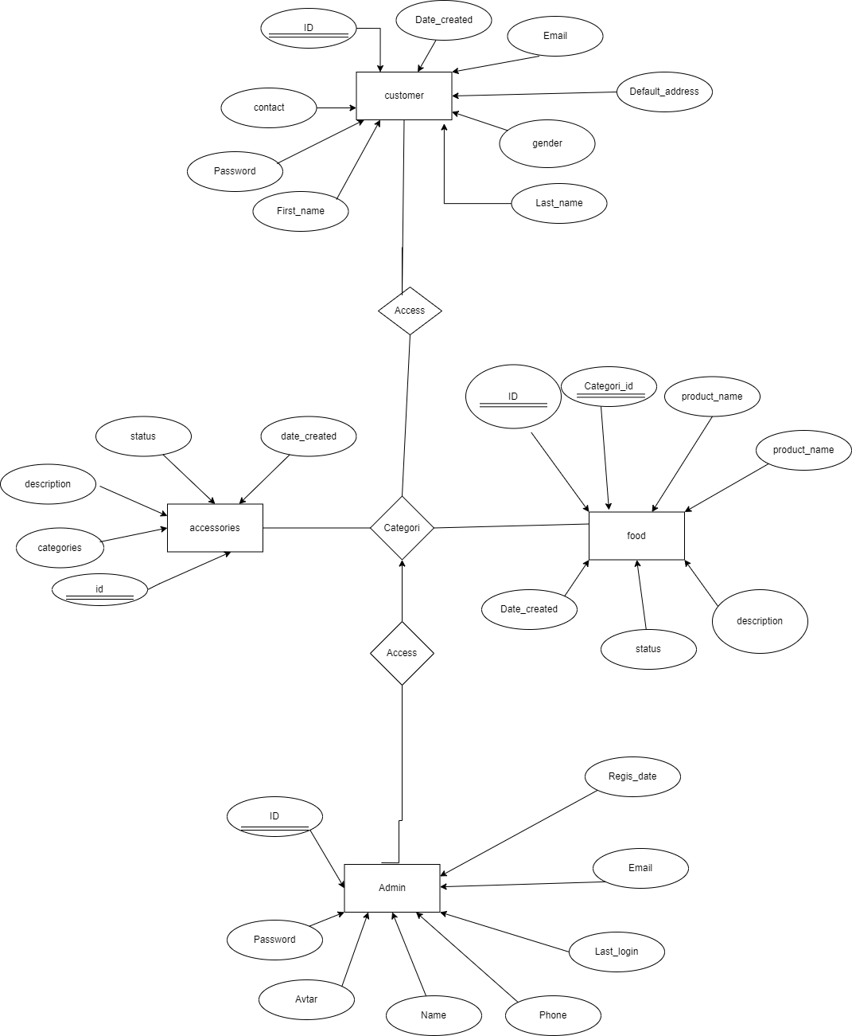**3.3 ER-DIAGRAM**

**3.4 USE CASE DIAGRAM:**

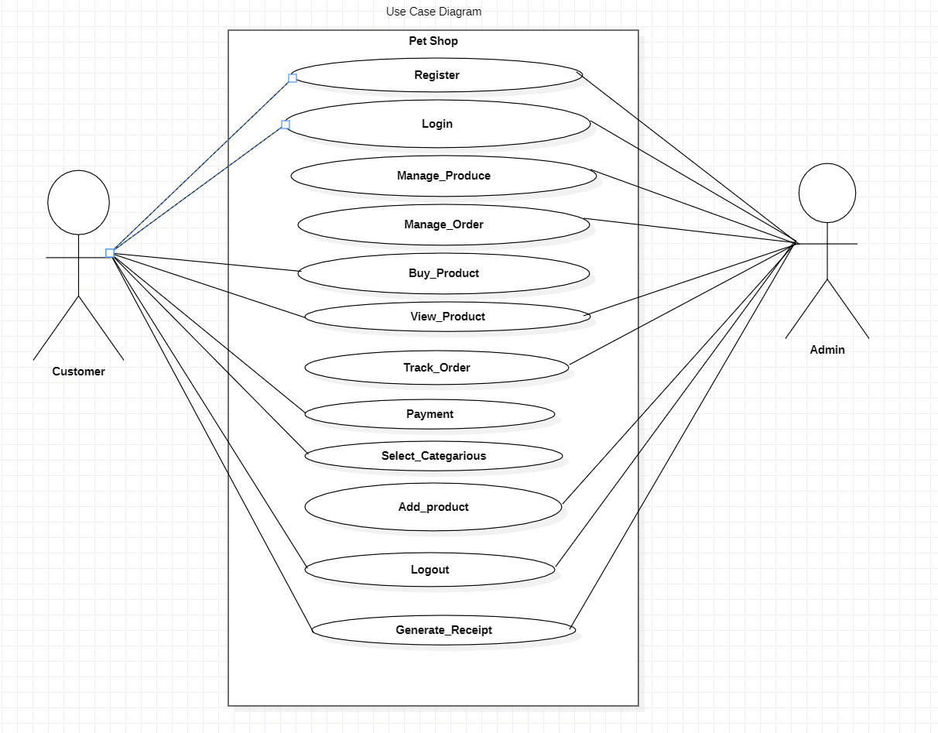

**3.5 CLASS DIAGRAM:**

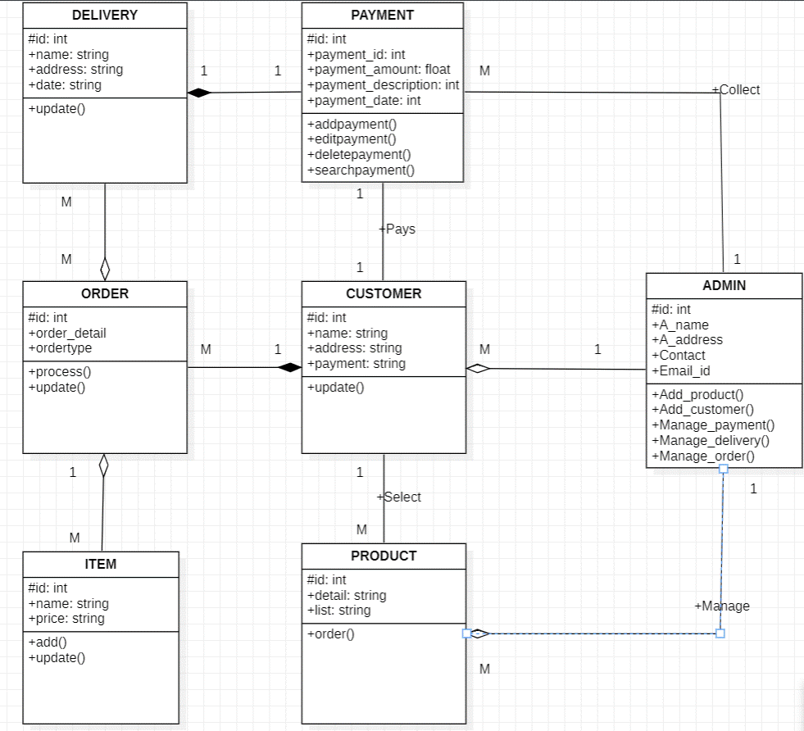

**3.6 ACTIVITY DIAGRAM:**

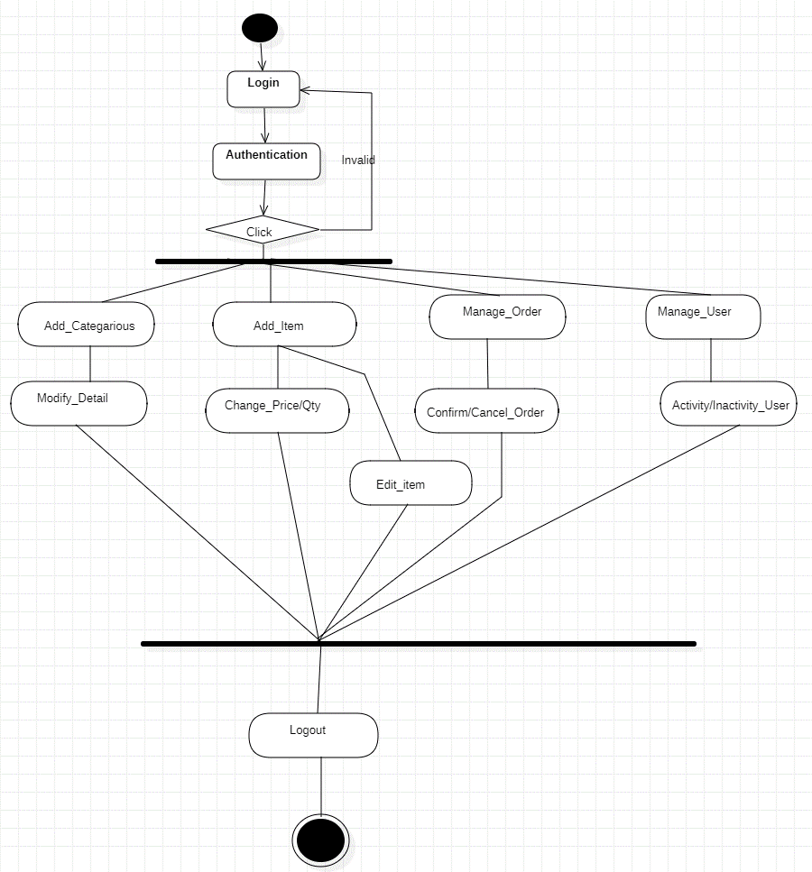**3.6.1 Activity diagram for admin**

**3.6.2 Activity diagram for customer**

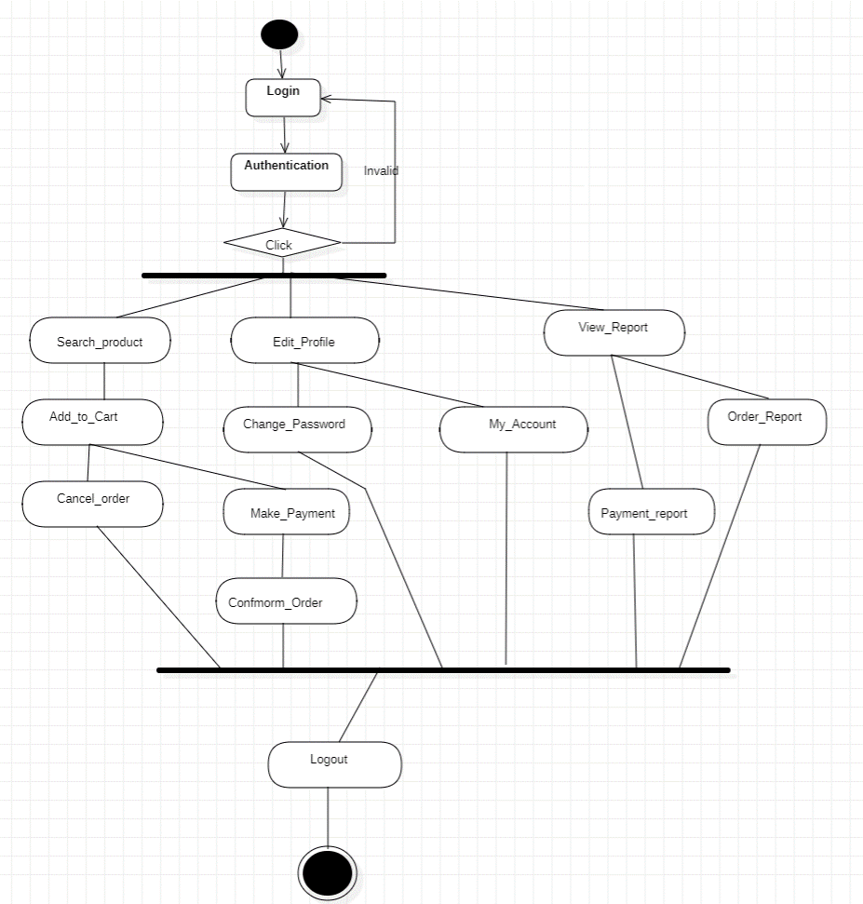

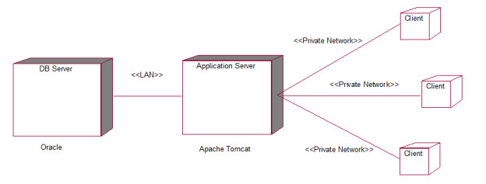**3.7 DEPLOYMENT DIAGRAM**

* 1. **MODULE HIERARCHY DIAGRAM**

login

User

Admin

Order

View Menu

Add cart

View Category

Contact

Search

Manage User

Manage Order

Manage Cart

Manage Menu

Manage Category

contact

**3.9 USER MANUAL/SAMPLE INPUT OUTPUT SCREENS: -**

**Admin login:**

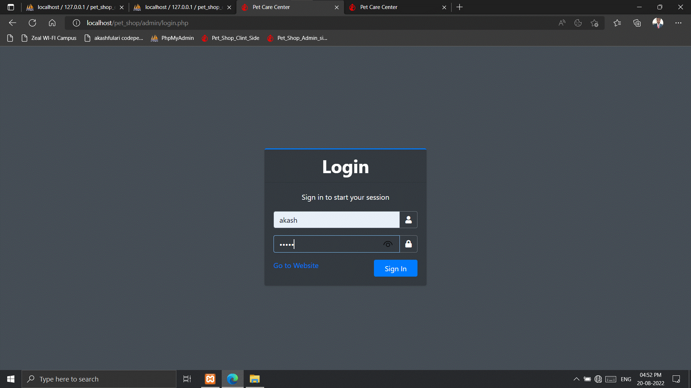

**DESCRIPTION: admin Can login using loginid amd password akash & akash is loginaid and password.**

**Admin Dash Board:**

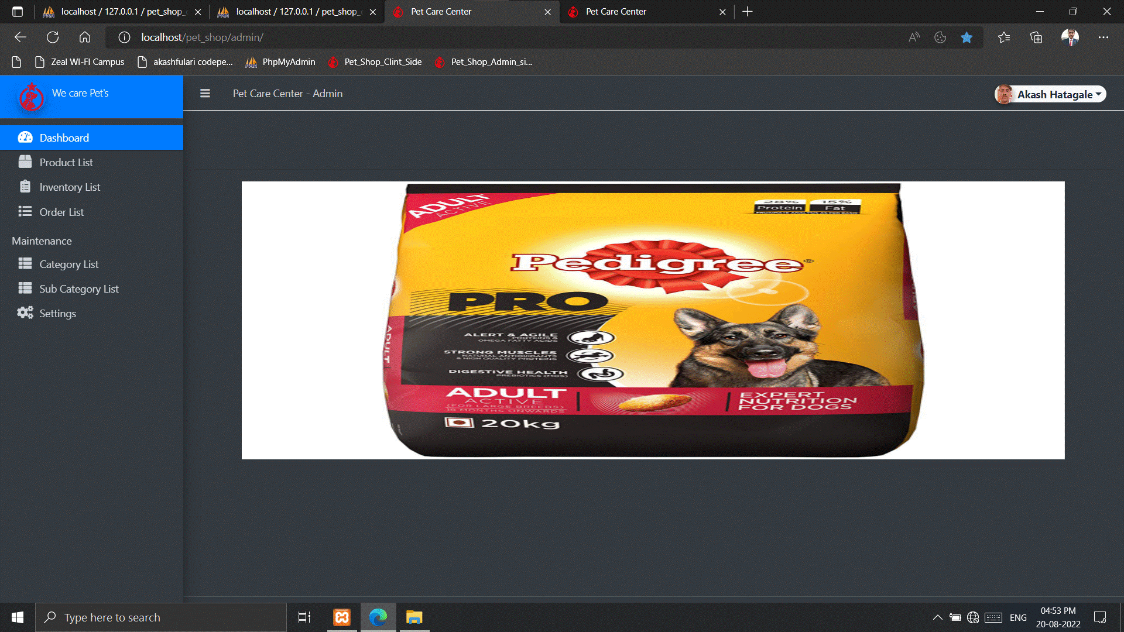

**DESCRIPTION: This is main dashboard for only admin side.**

**Admin Profile:**

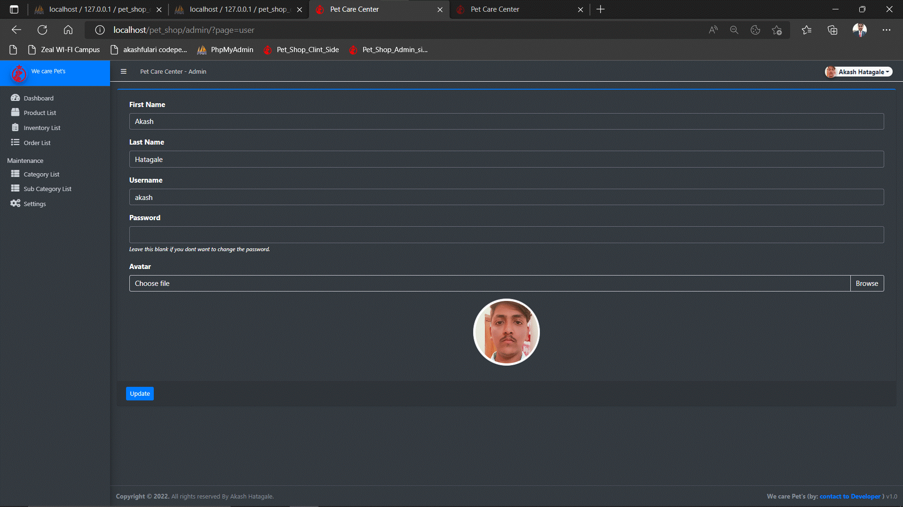

**DESCRIPTION: admin can edit his profile like id and password.**

**Admin Order List:**

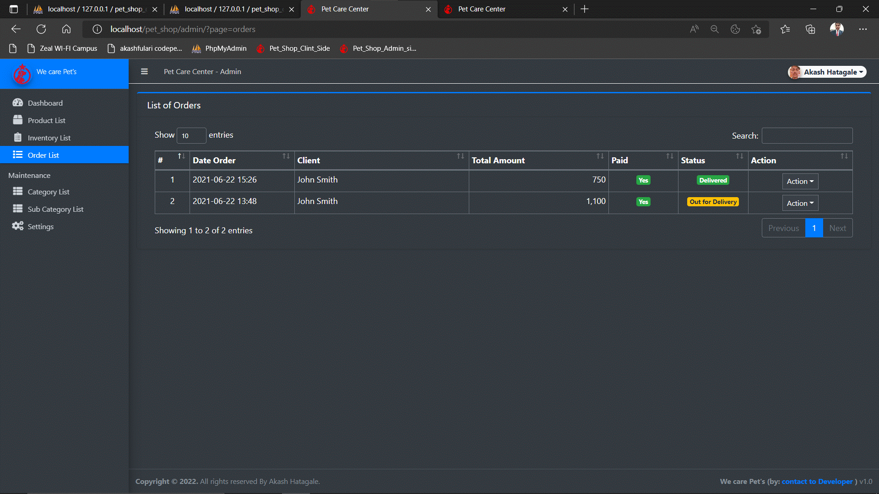

**DESCRIPTION: Admin can manage daily order.**

**Admin Inventory:**

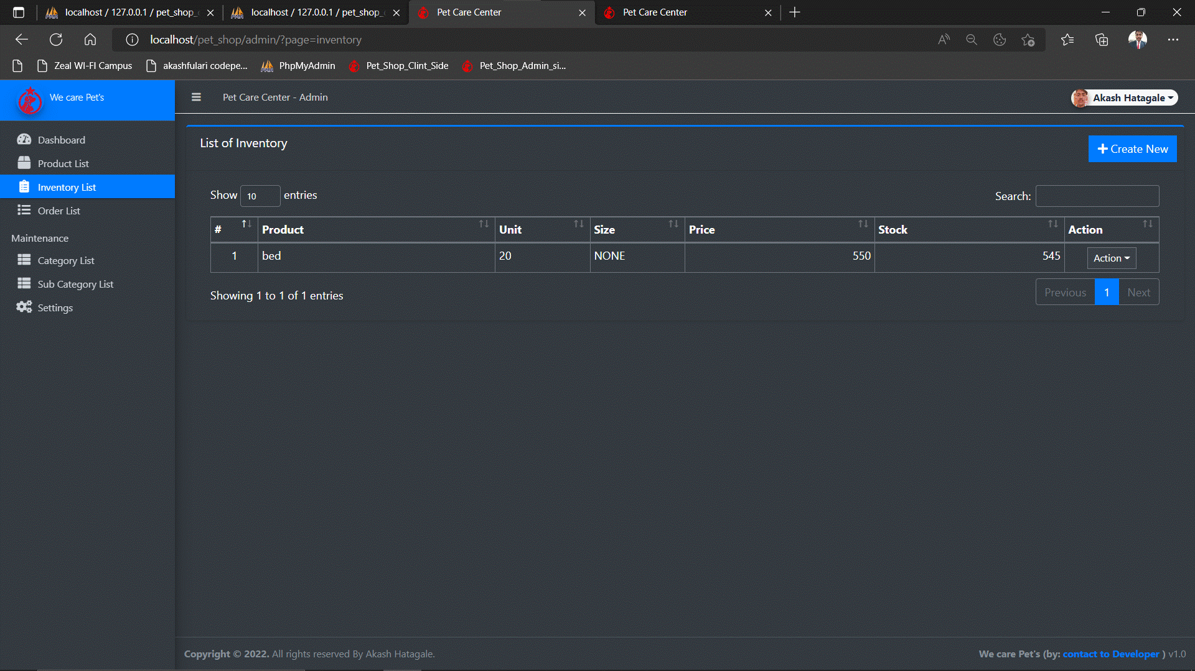

**DESCRIPTION: Admin also add inventory daily od monthly.**

**Product Category:**

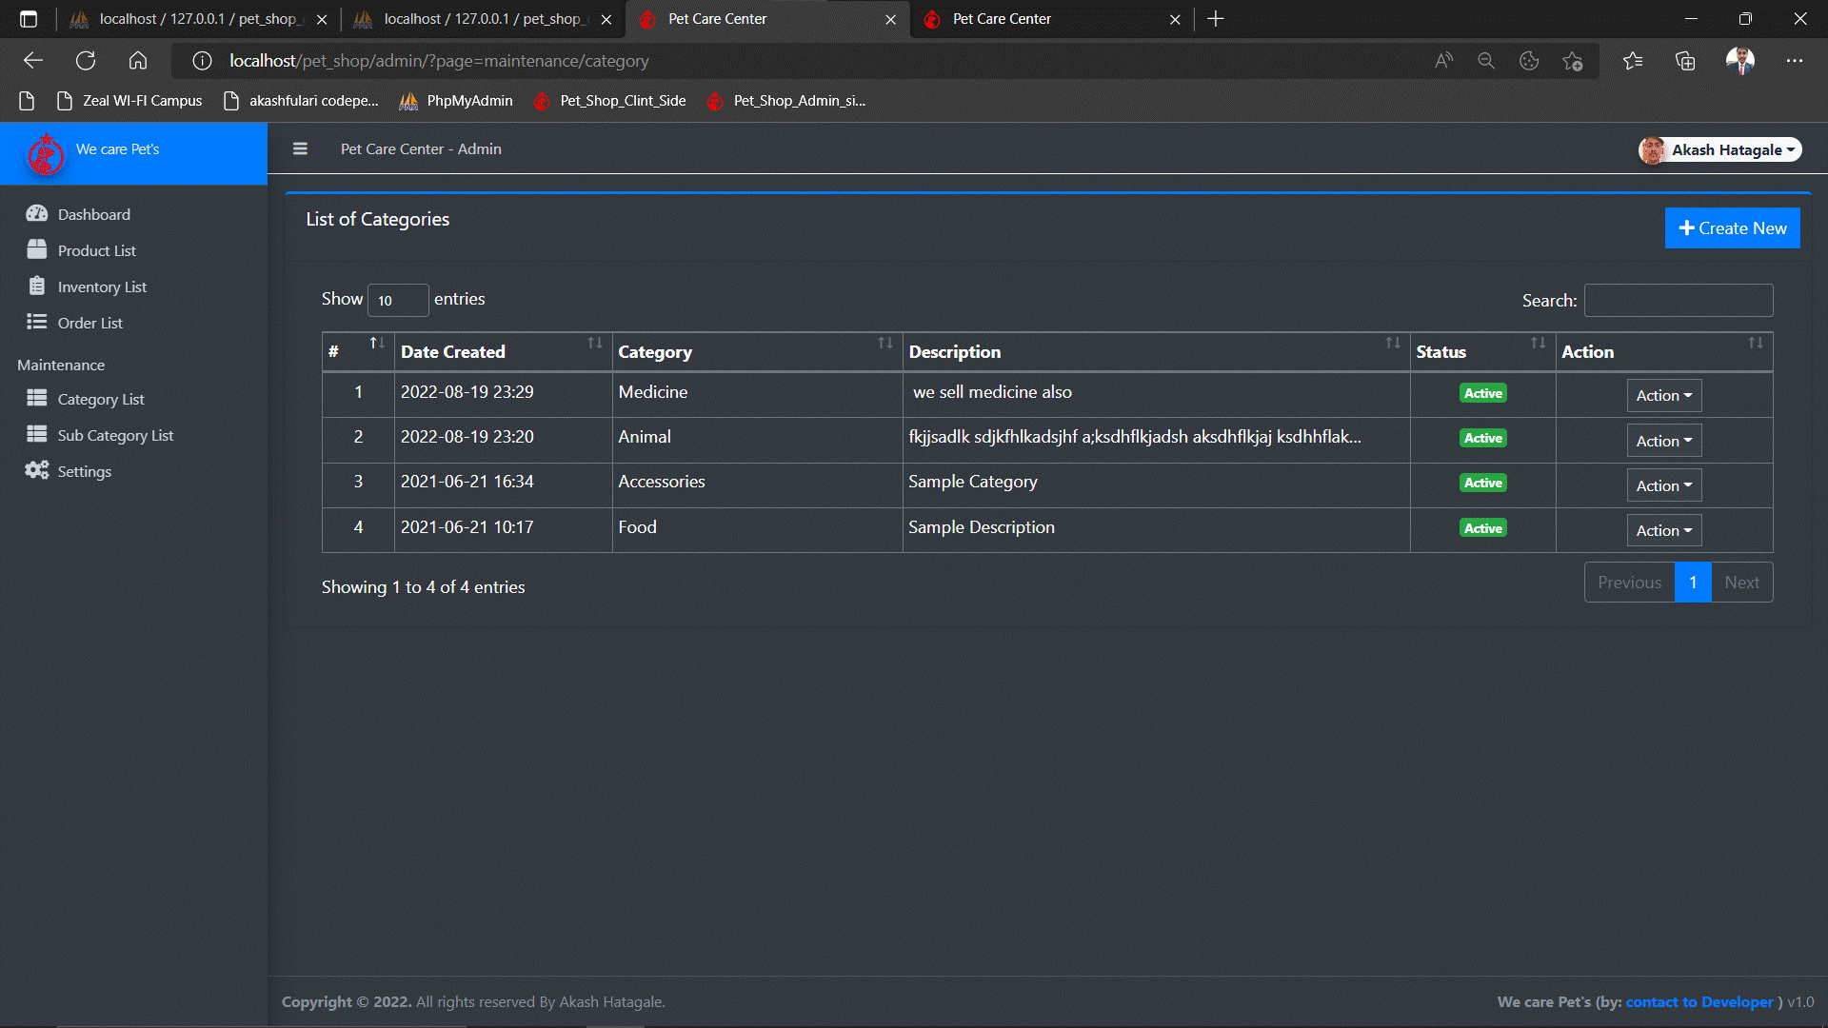

**DESCRIPTION: Admin can add product category wise end sort it.**

**Product List:** 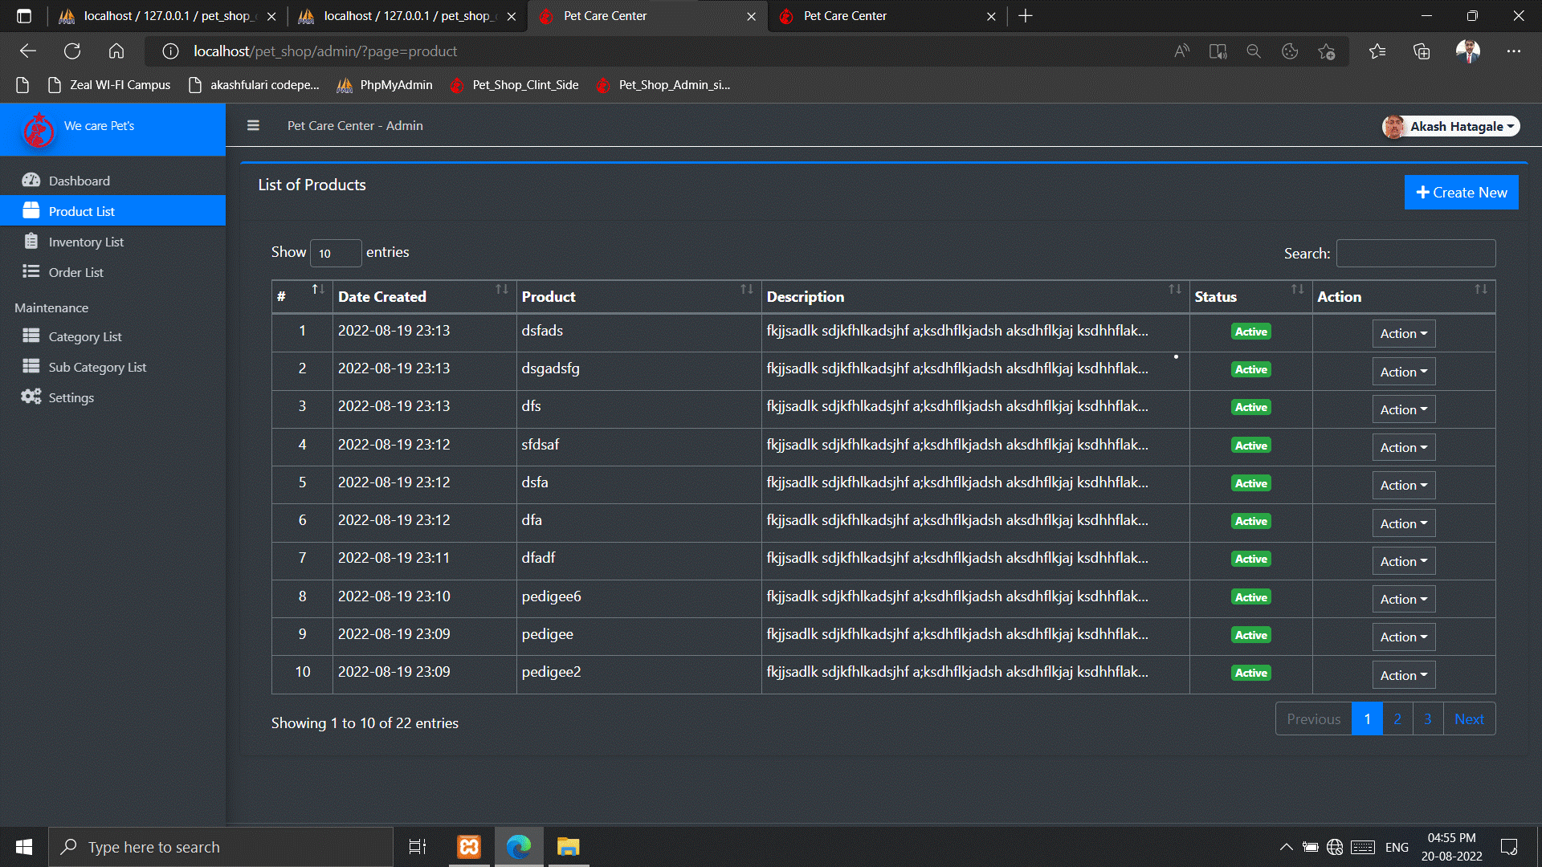

**DESCRIPTION: admin can edit product list.**

**Admin Setting:**

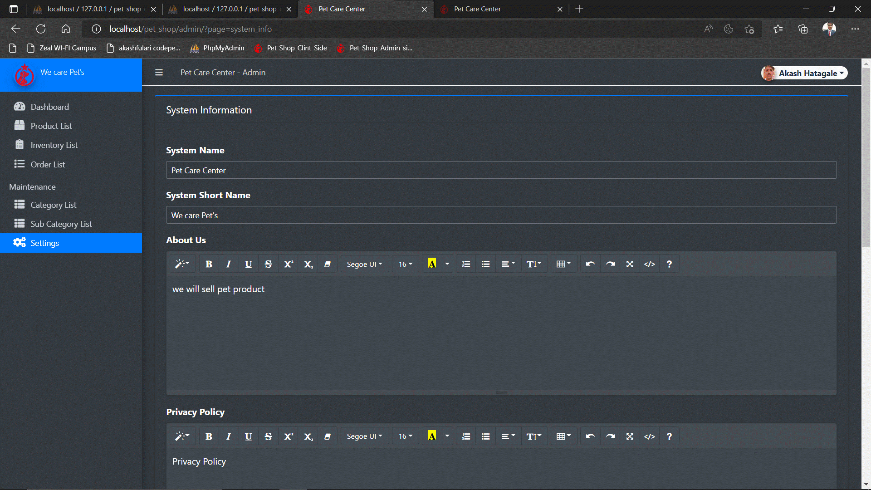

**DESCRIPTION: admin can change web setting and many more.**

**Setting 02:**

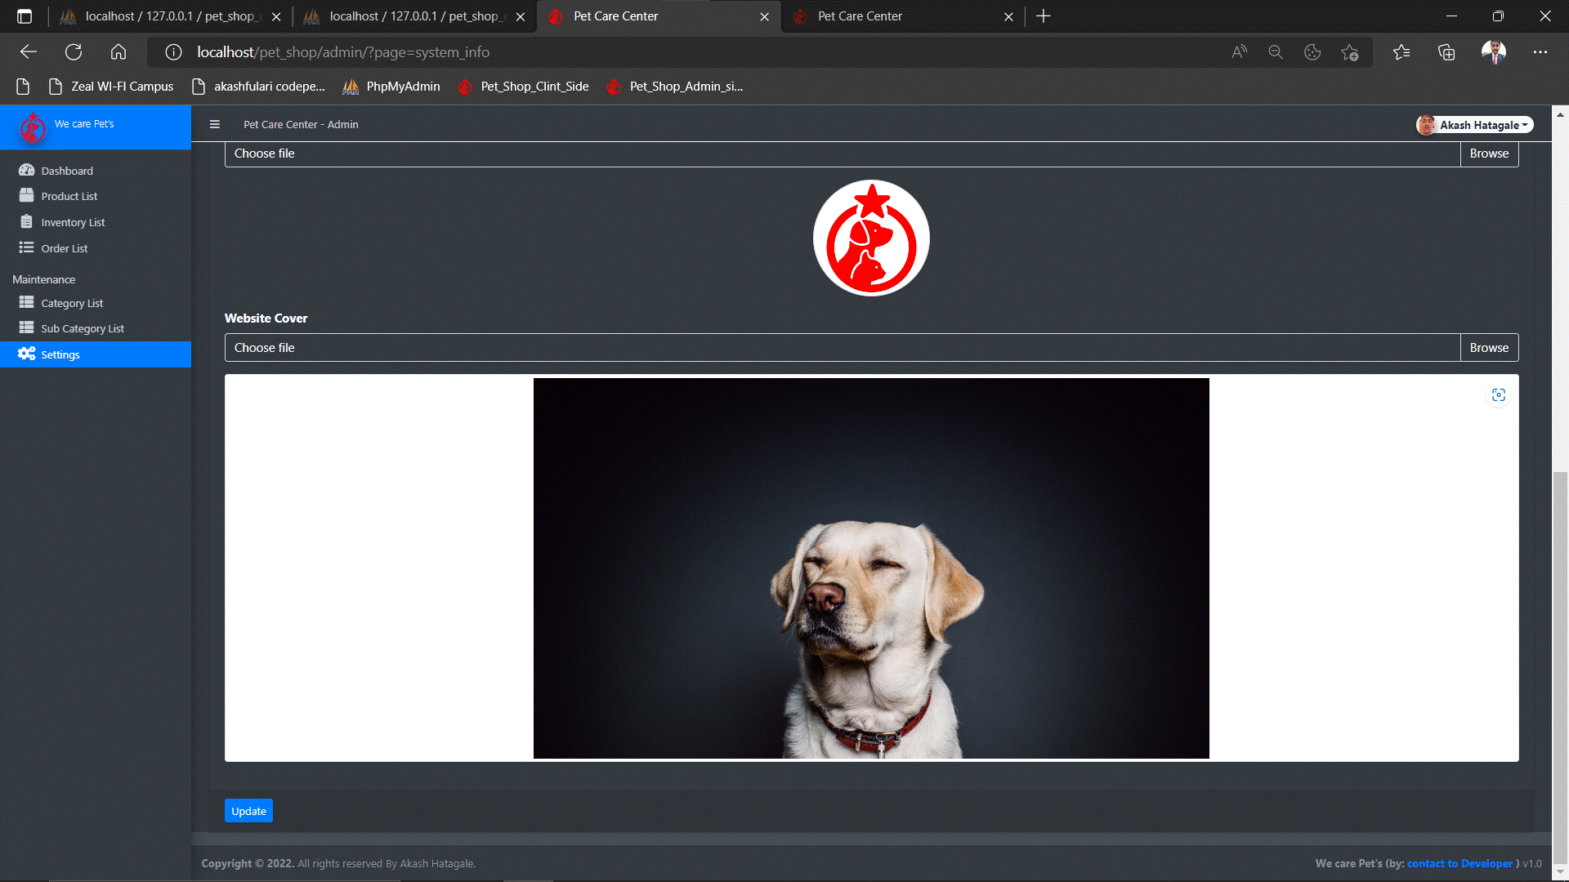

**DESCRIPTION: same as above.**

**Product Sub Category:**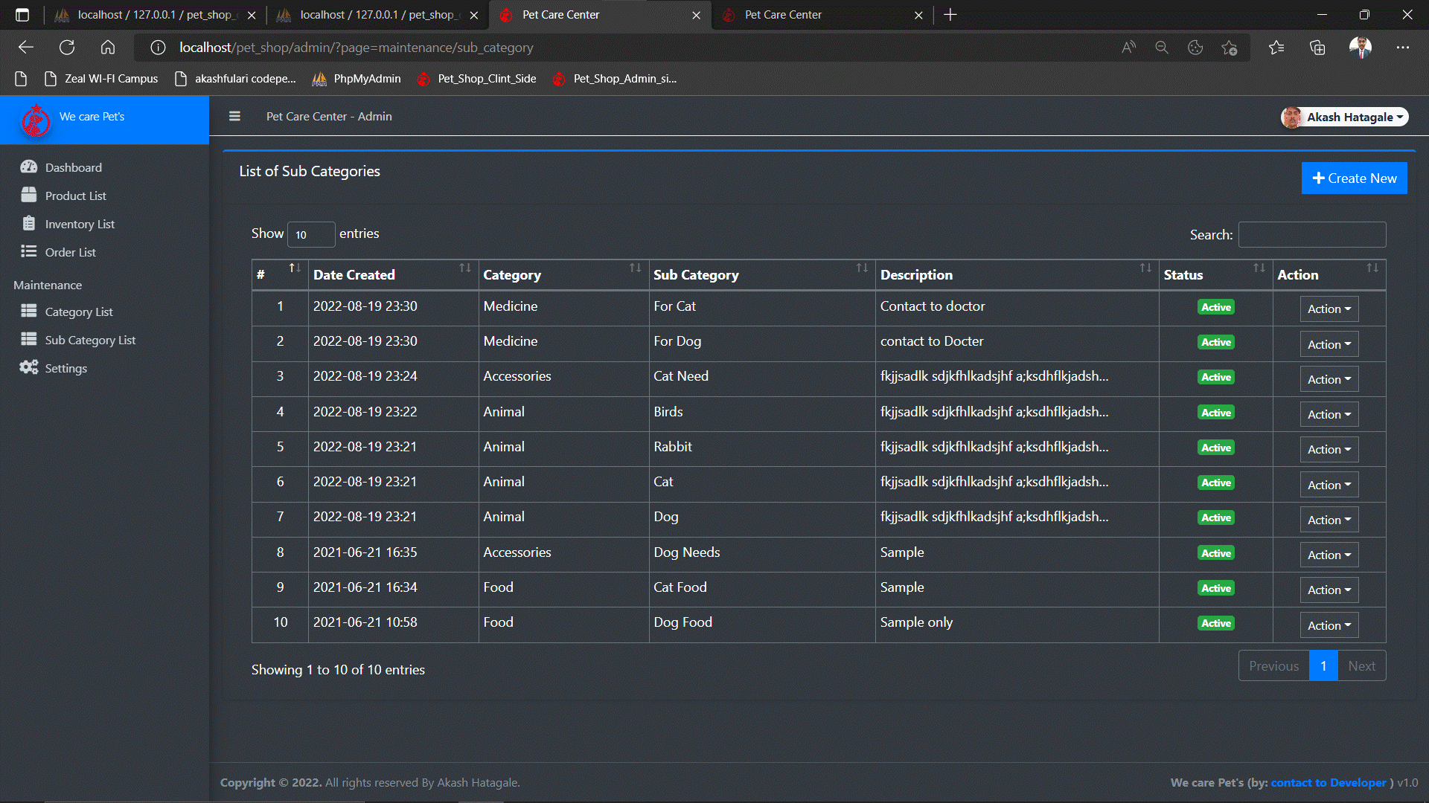

**DESCRIPTION: Add product category wise.**

**Add category:**

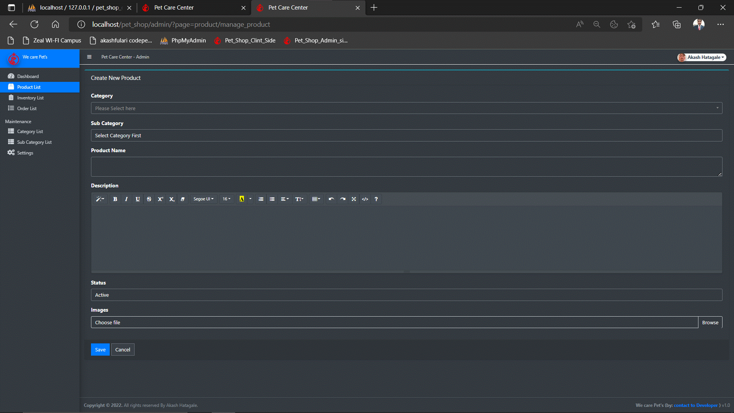

**DESCRIPTION: Admin can Add multiple category.**

**Create Inventory:**

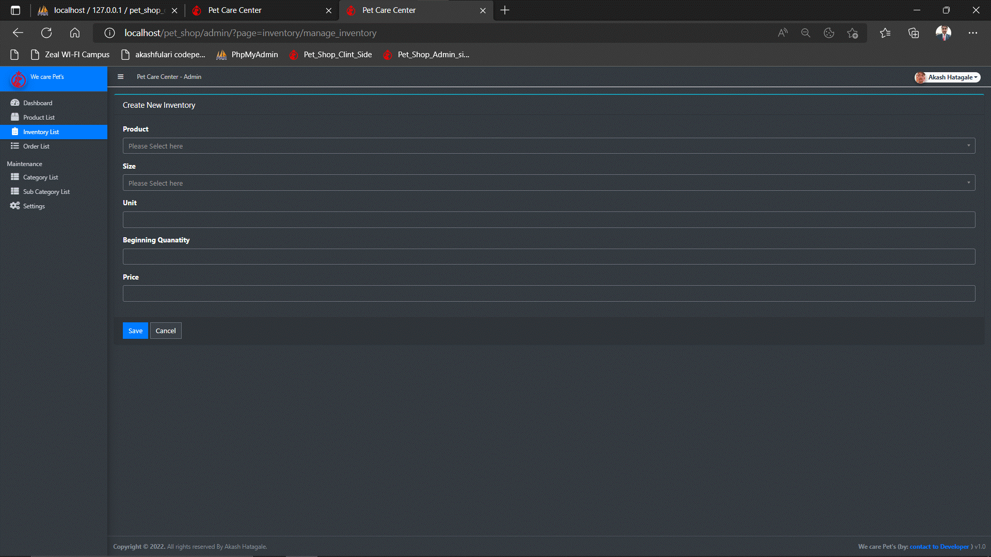

**DESCRIPTION: admin can create new inventy list**

**Login page:**

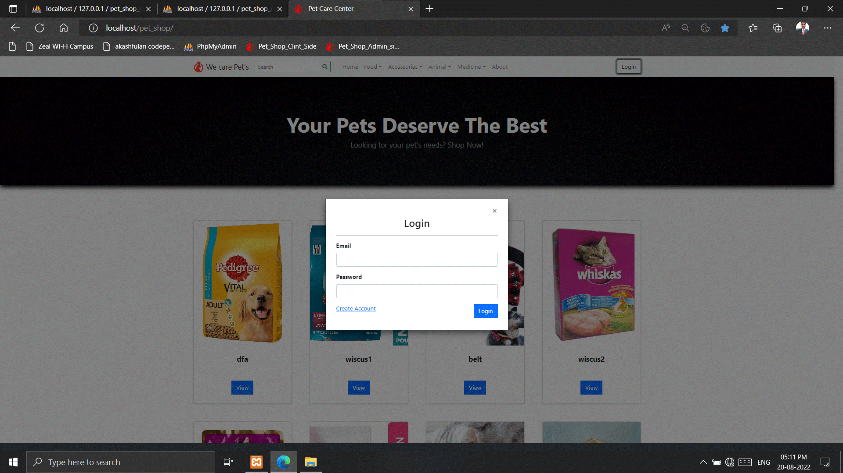

**DESCRIPTION: This is client side login page.**

**BASE Page:**

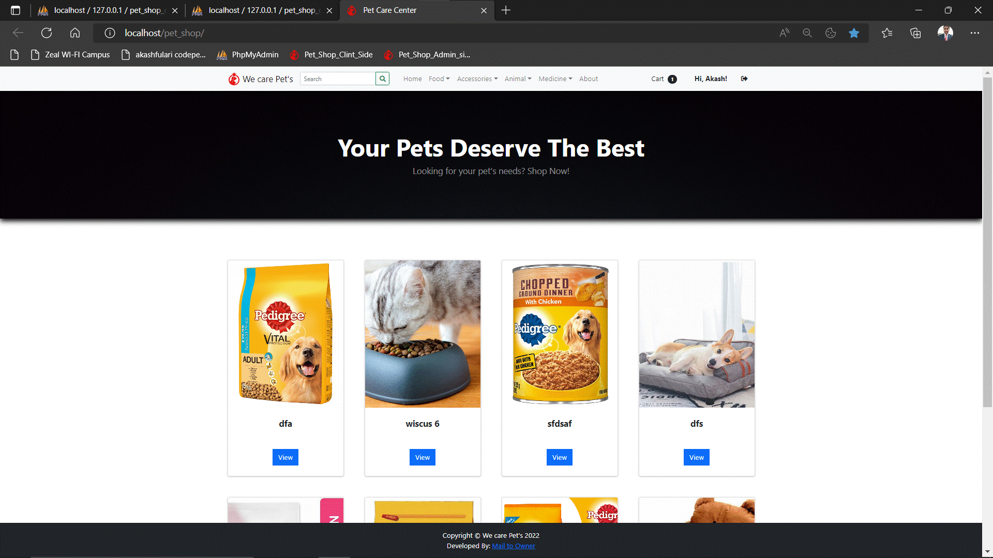

**DESCRIPTION: Dash board for client side.**

**Create Account:**

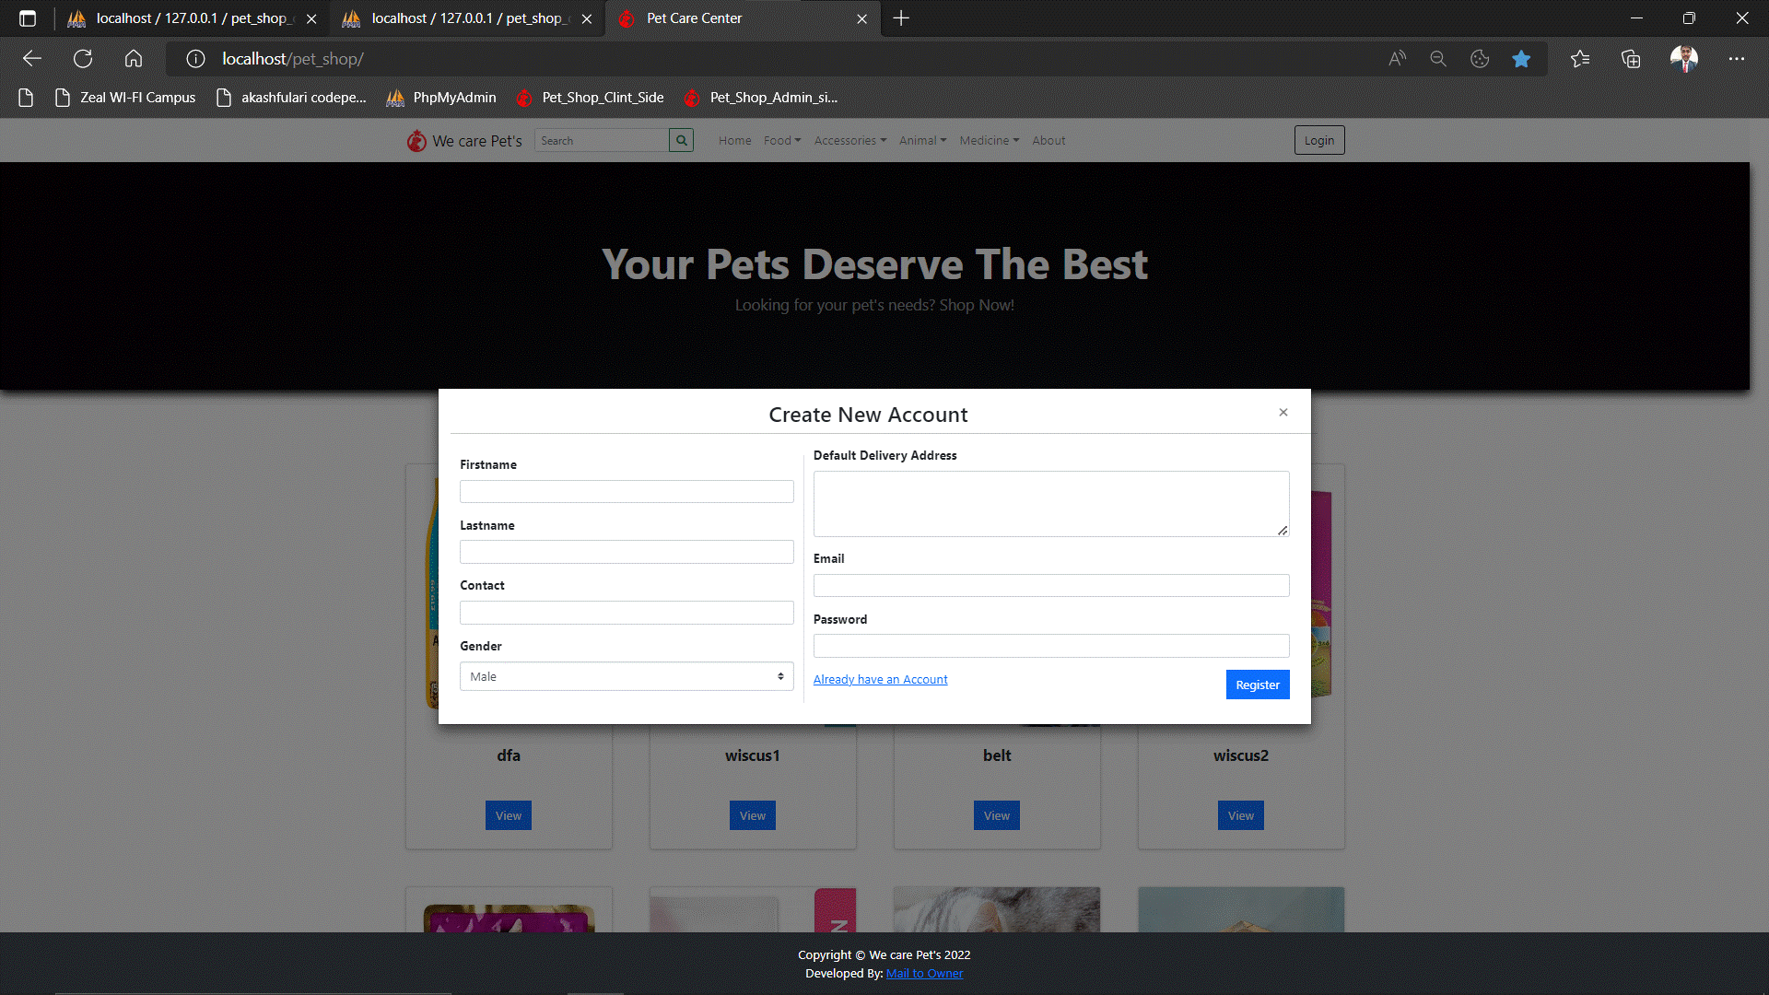

**DESCRIPTION: Client can create Account Filling above detail.**

**Client Update detail:**

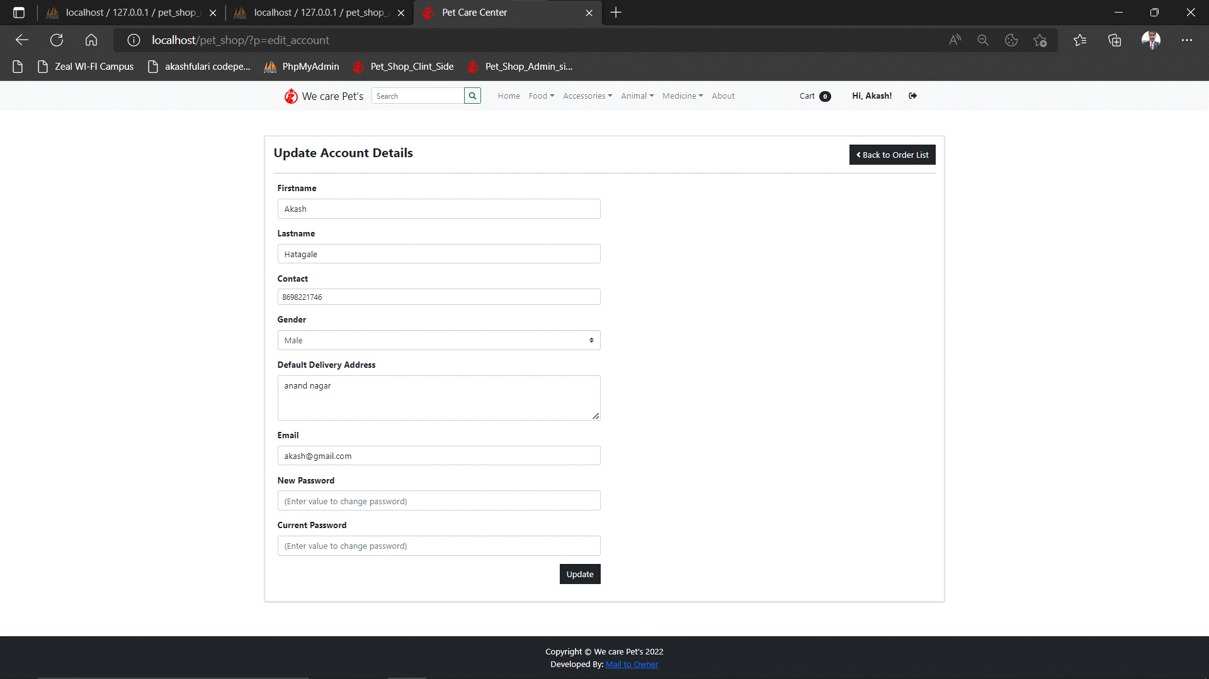

**DESCRIPTION: Client can update has profile detail**

**Food Drop Down Page:**

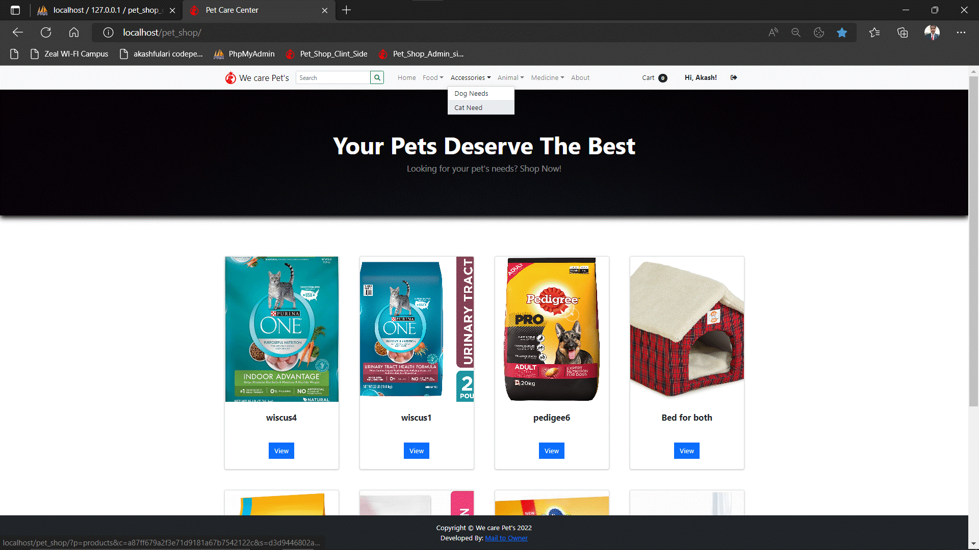

**DESCRIPTION: Food category pet wise.**

**Cat Drop Down Page:**

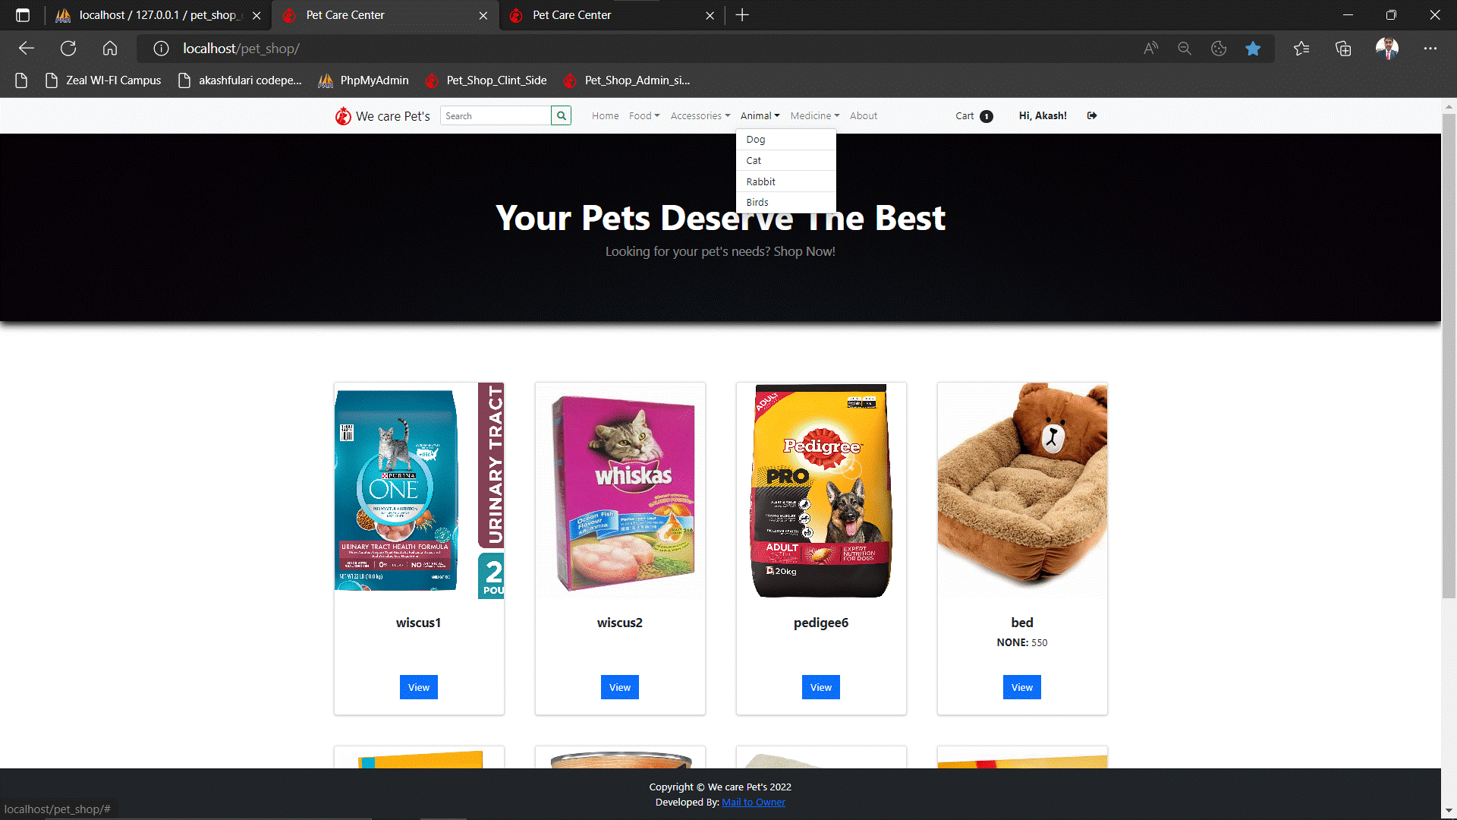

**DESCRIPTION: This is cat drop down list.**

**Food category:**

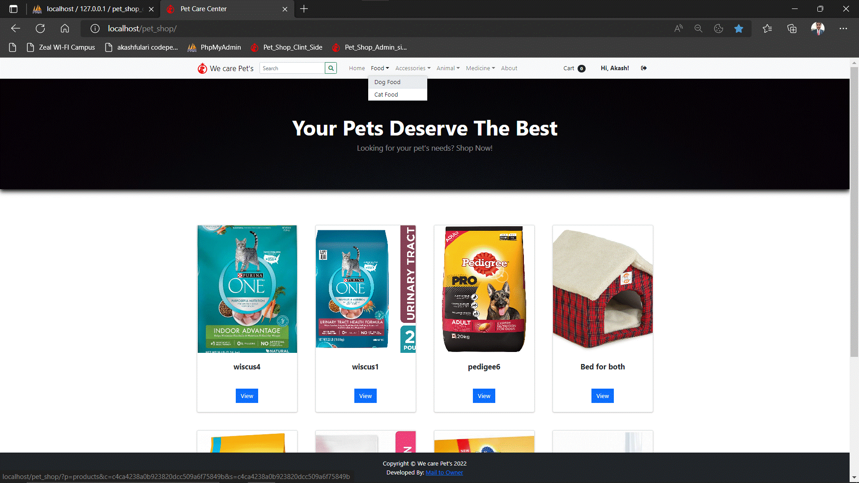

**DESCRIPTION: Client can see food category wise.**

**Cart Item:**

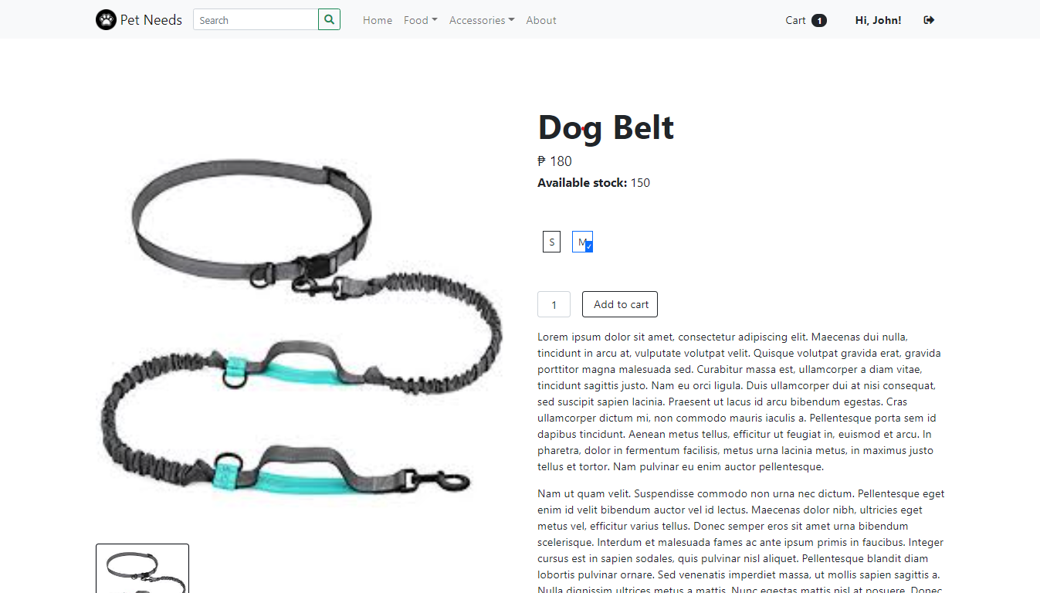

**DESCRIPTION: client can view product detail simply clicking view button**

**Order List:**

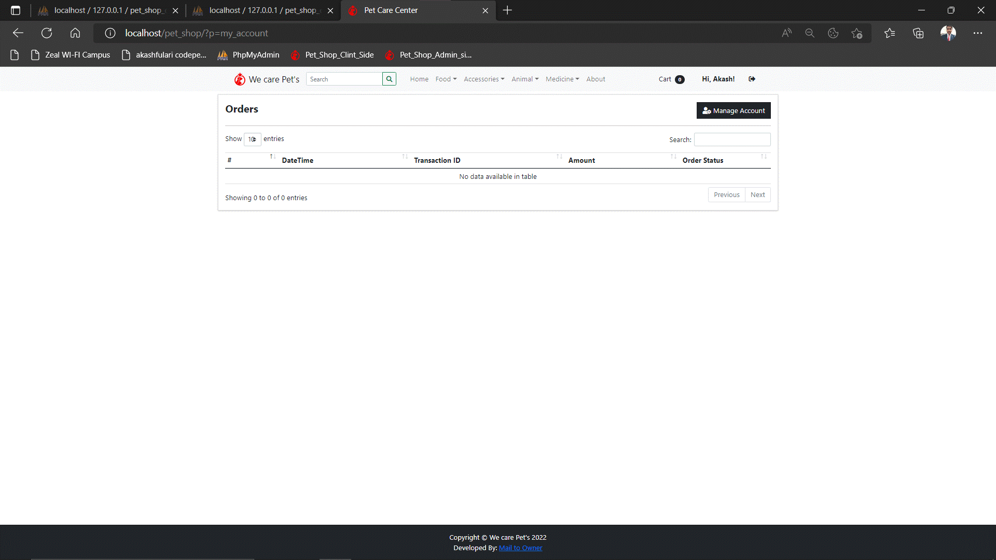

**DESCRIPTION:**

**Order page:**

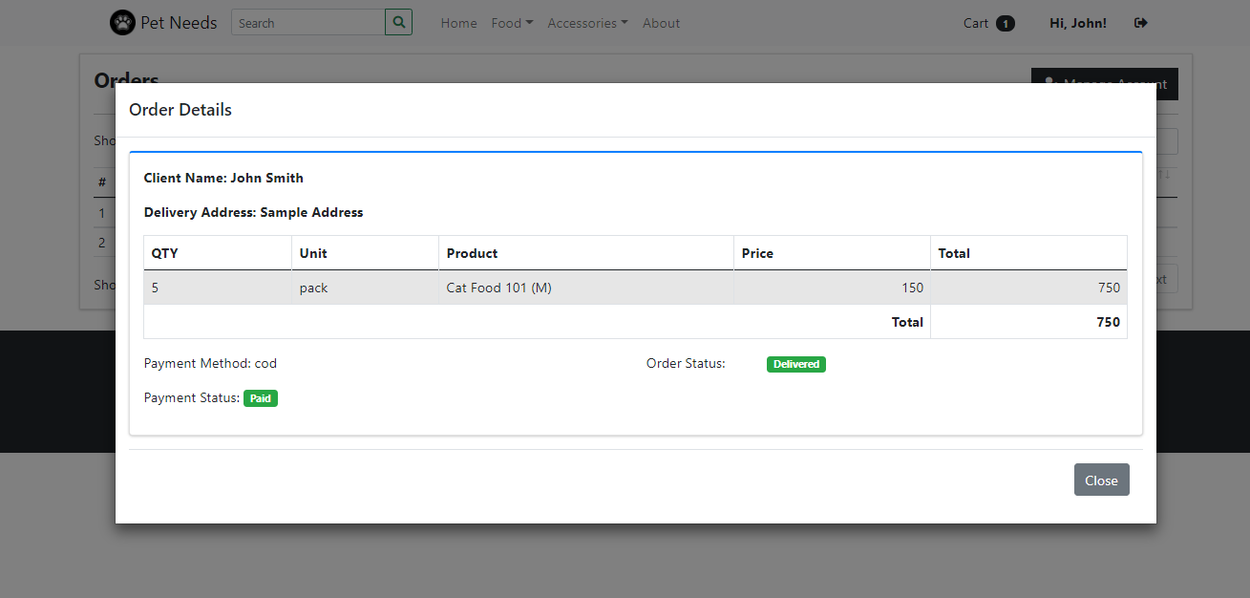

**DESCRIPTION: The look of order page**

**Cart List Page:**

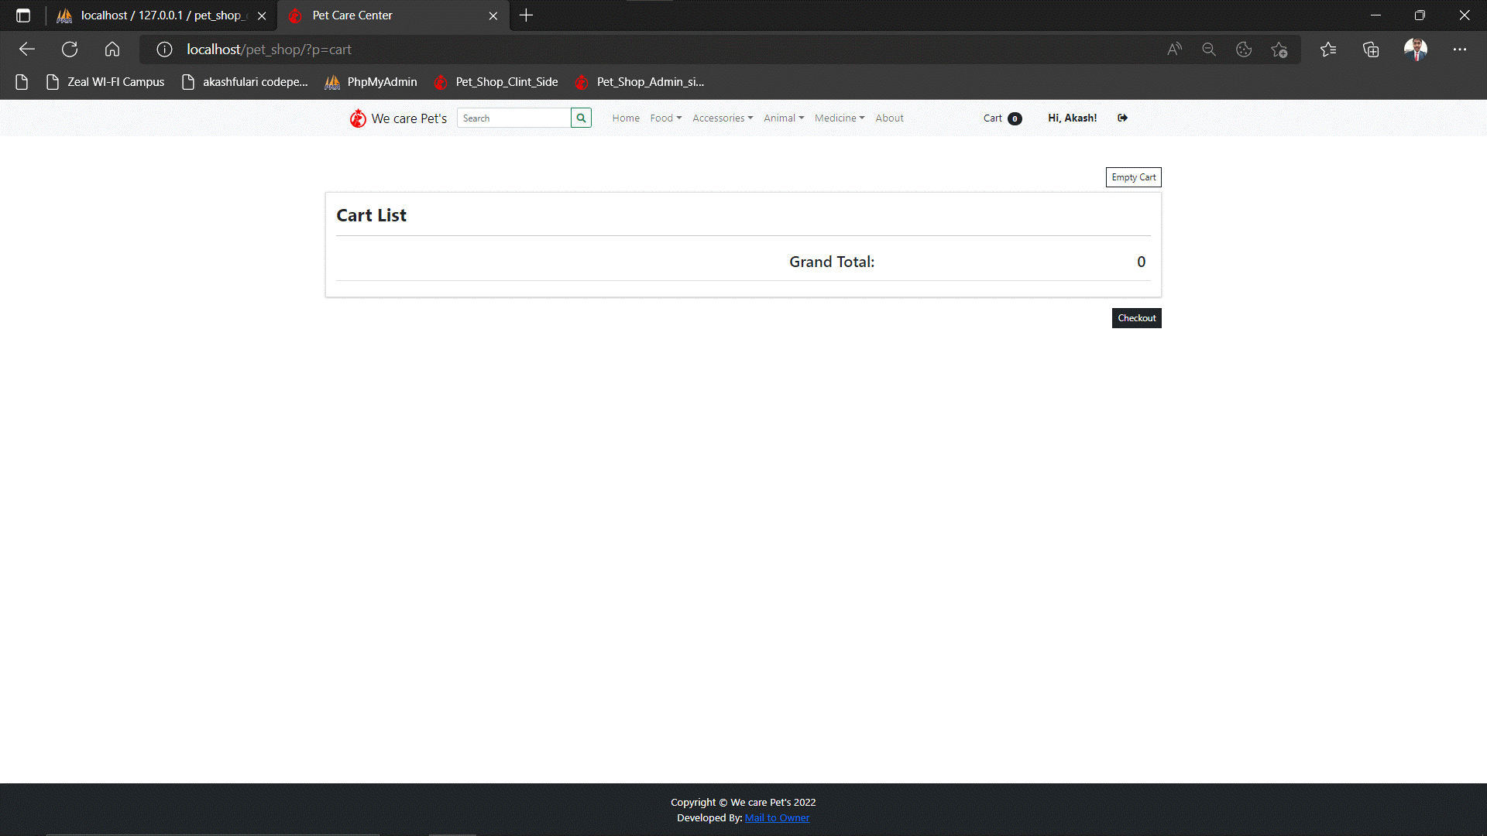

**DESCRIPTION: Client can see all cart item and place order.**

**Check Out Page:**

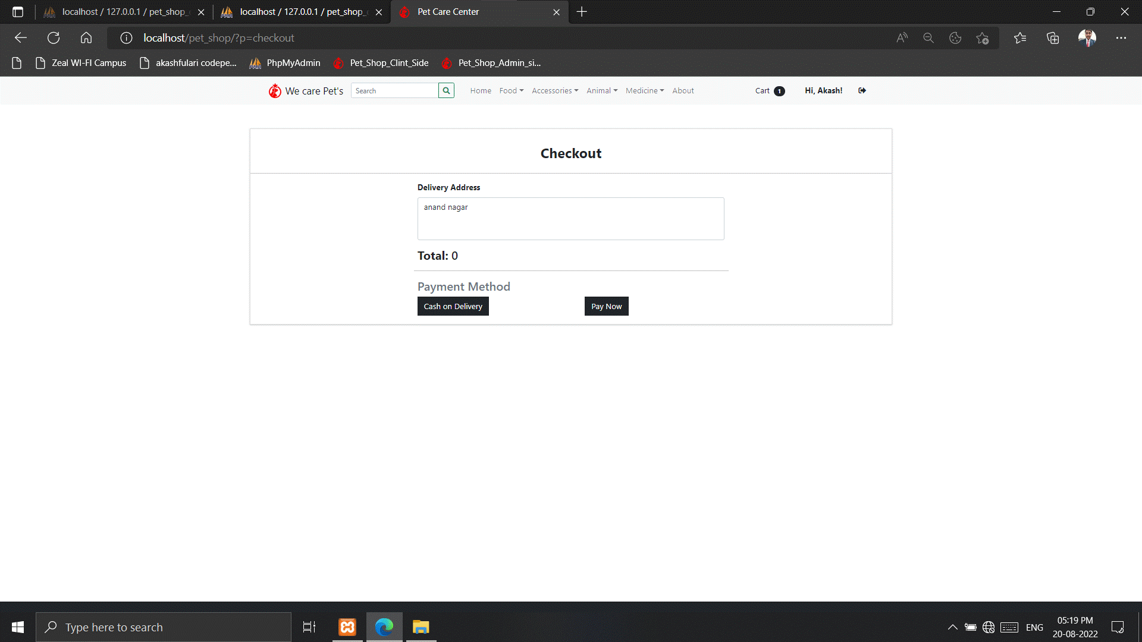

**DESCRIPTION: client can choose payment method**

**Delete Cart Item :**

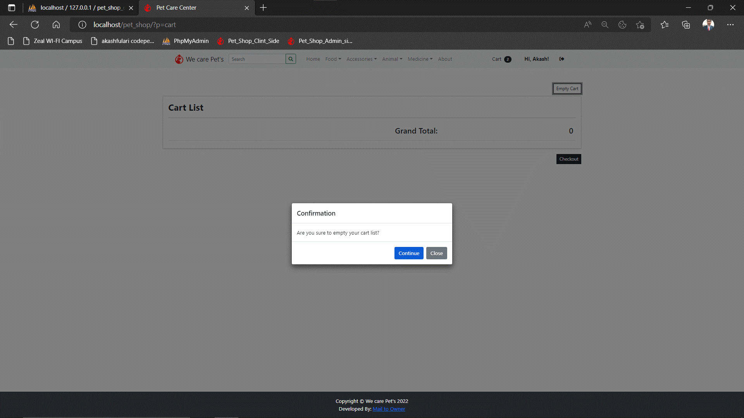

**DESCRIPTION: Client can delete cart Item.**

**About:**

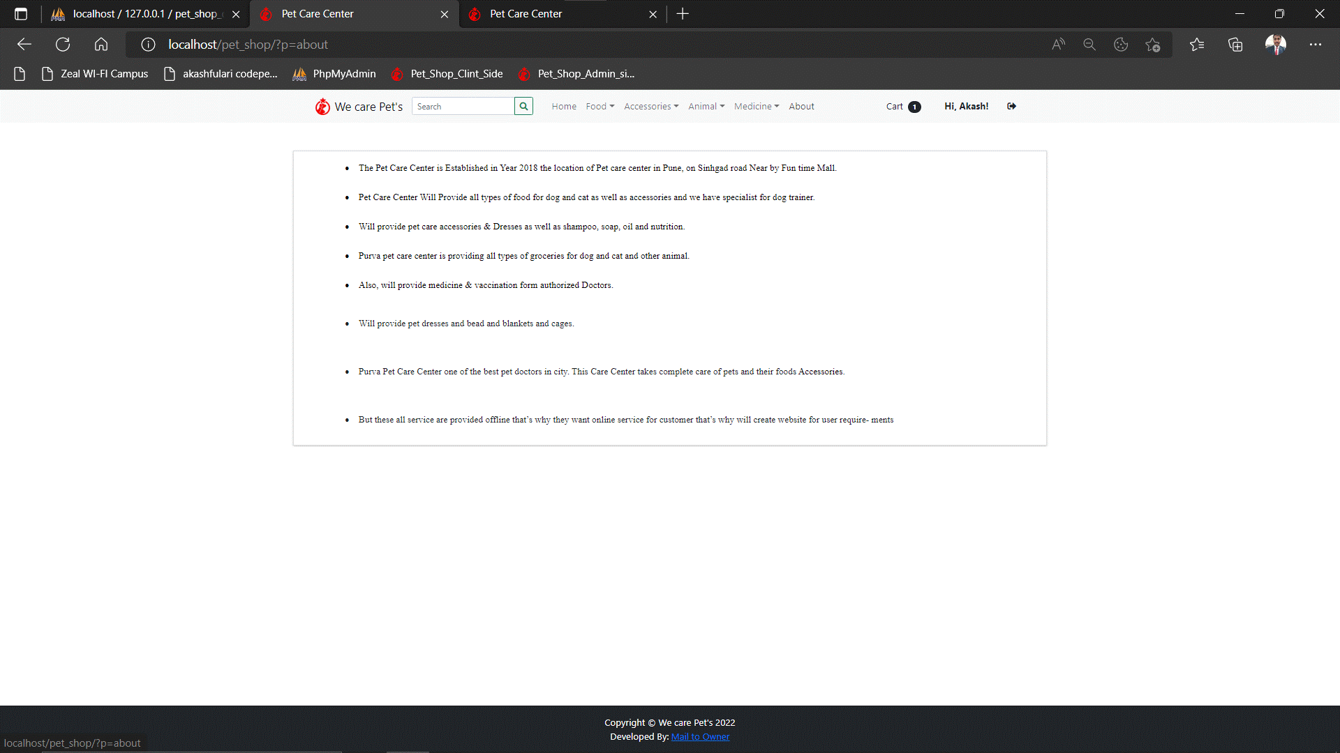

**DESCRIPTION: About Owner Shop And Owner Detail**

**Database:**

**All Tables:**

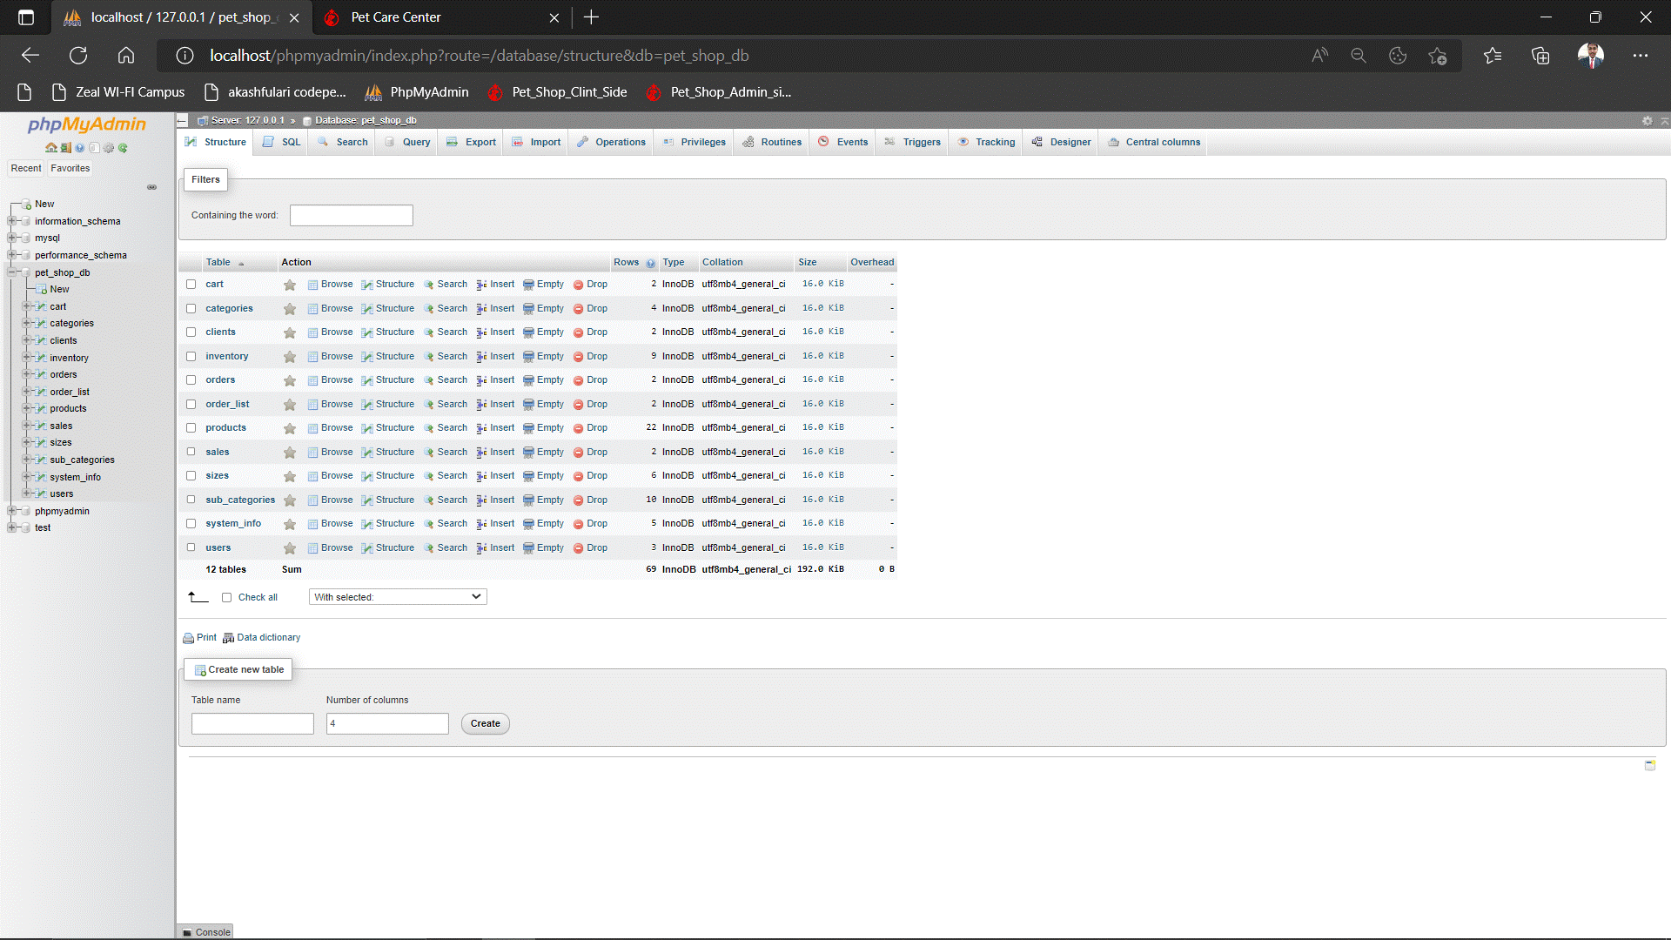

**Cart Table:**

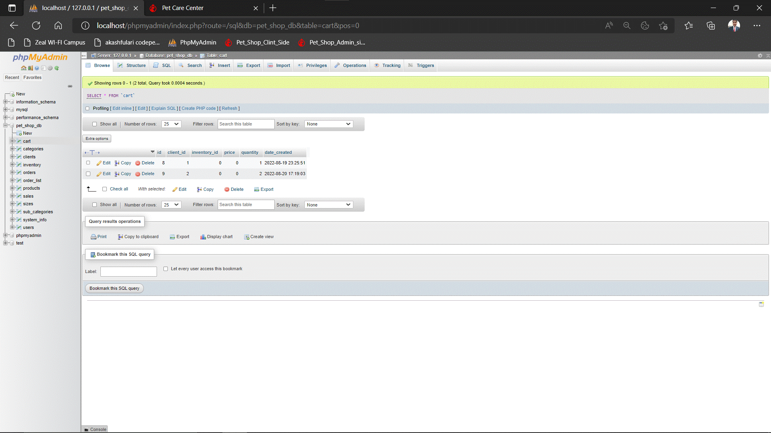

**Category table:**

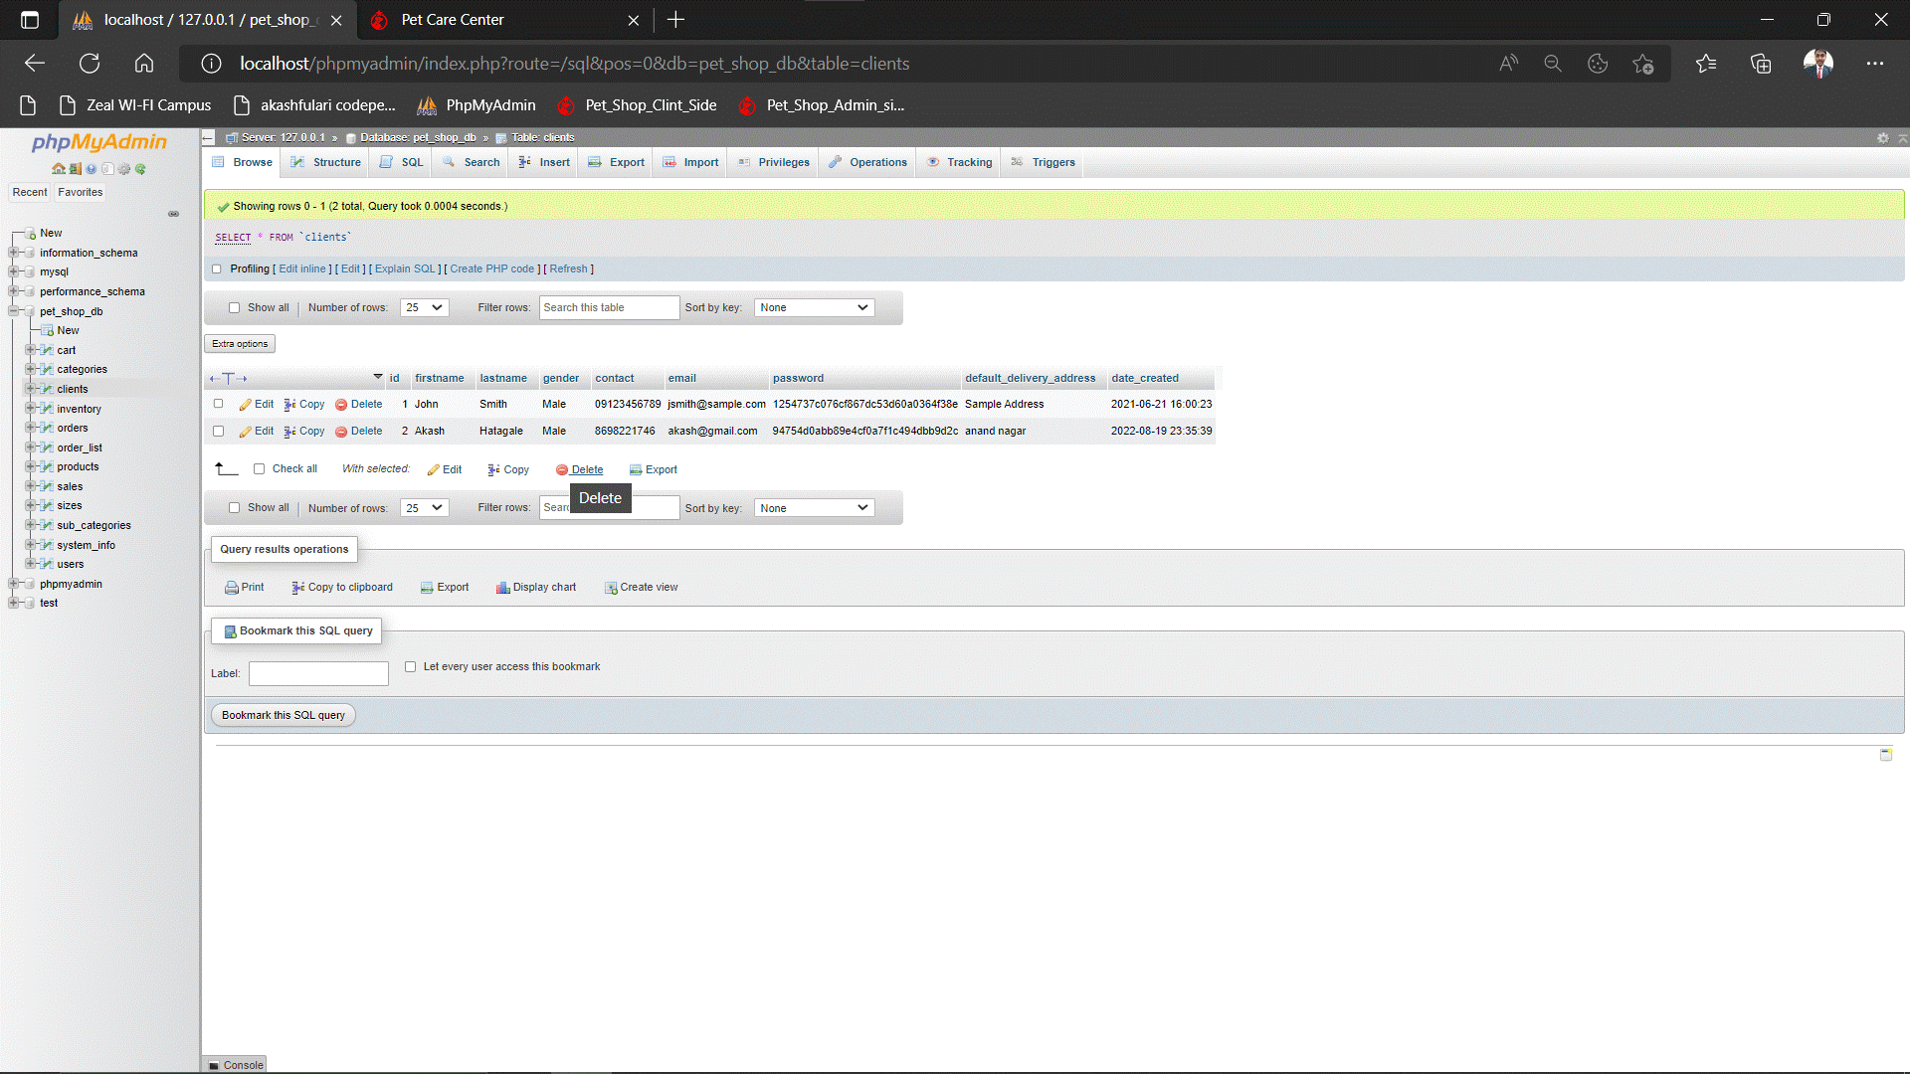

**Client table:**

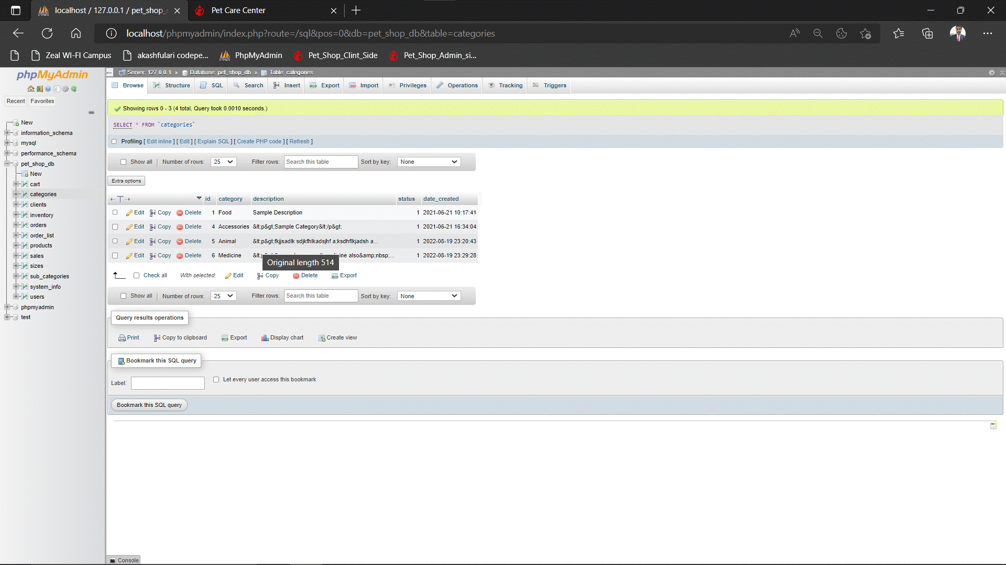

**Inventory table:**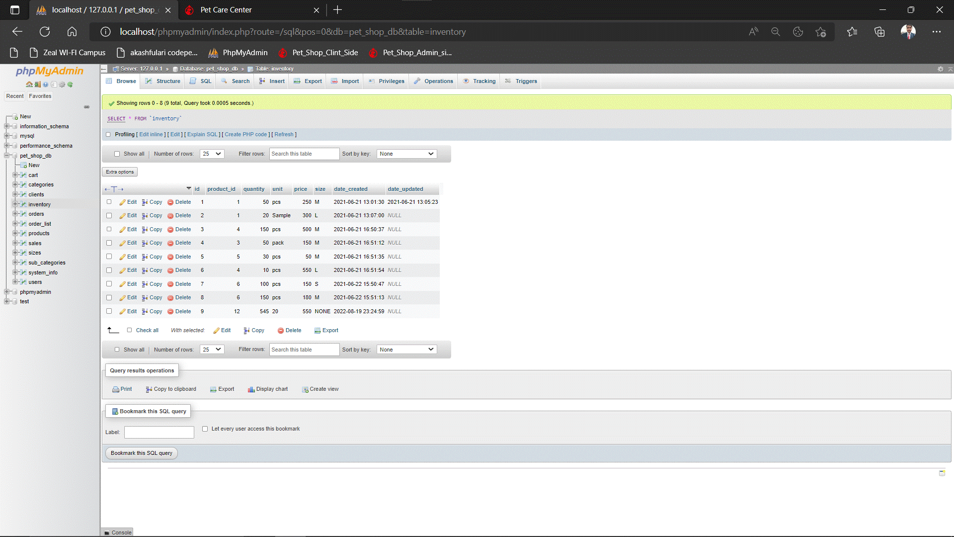

**Order_List Table:**

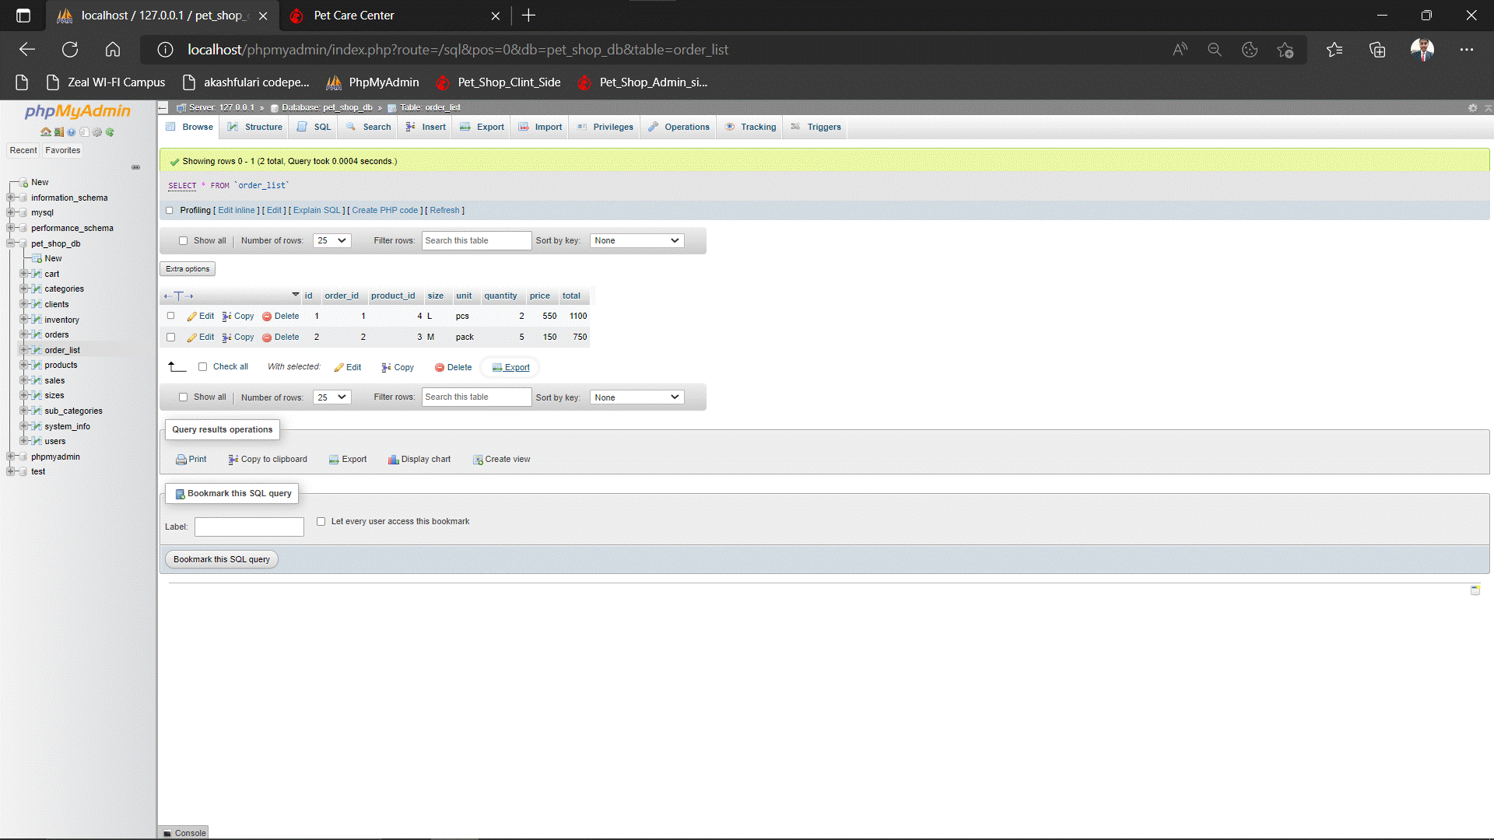

**Order Table:**

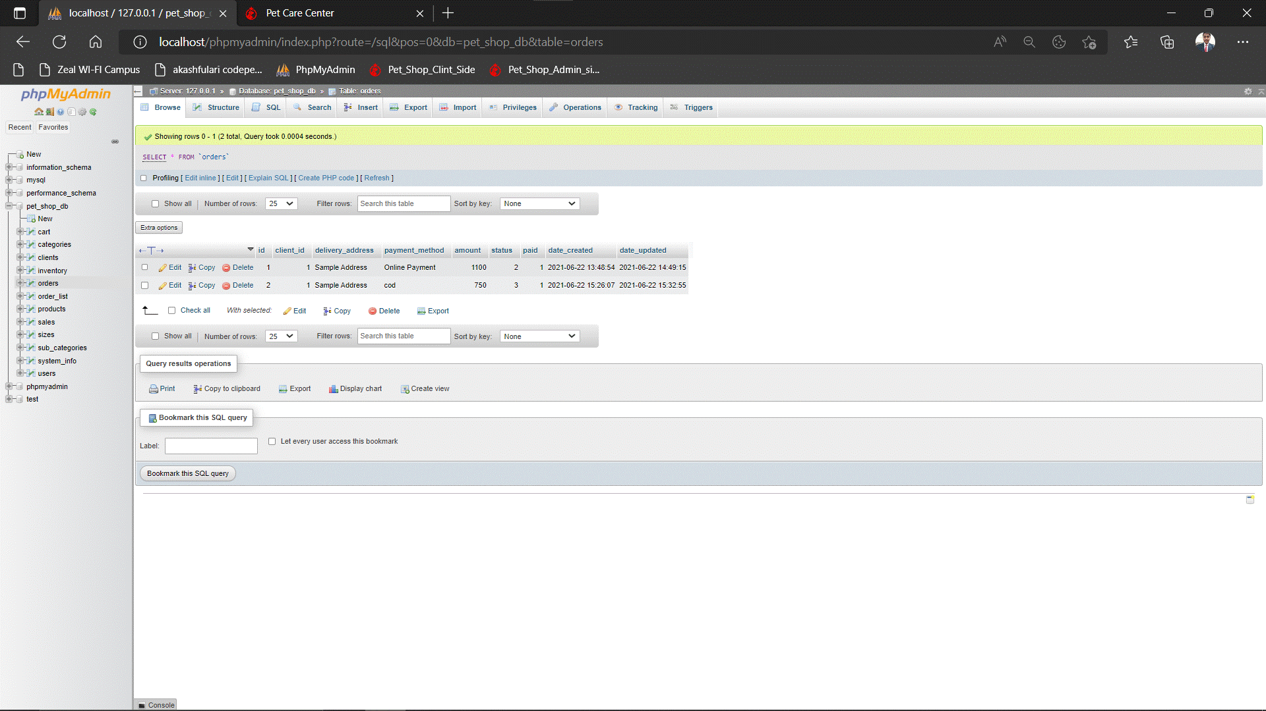

**Product Table:**

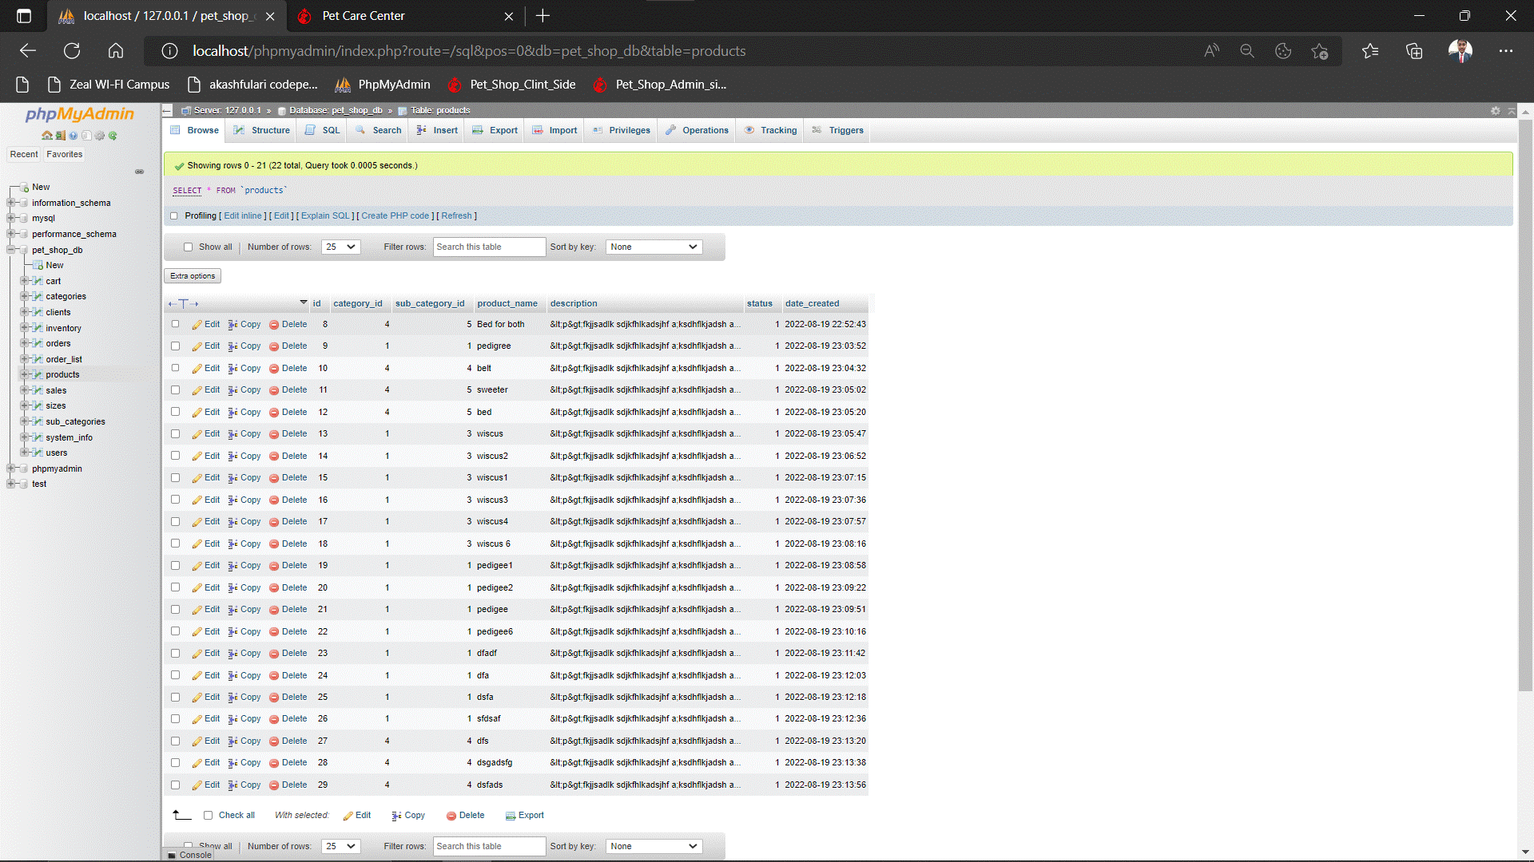

**Sale Table:**

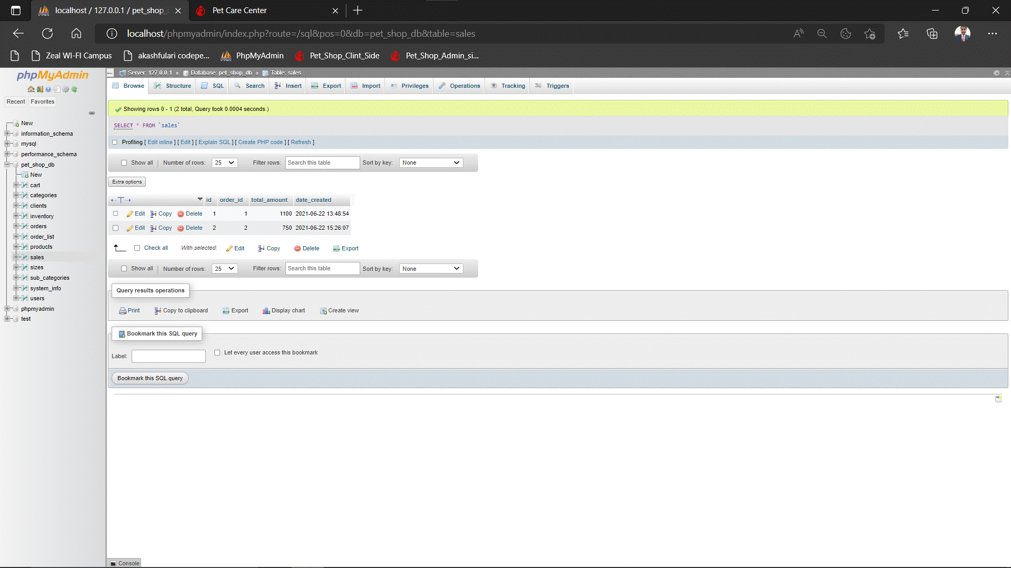

**Size Table:**

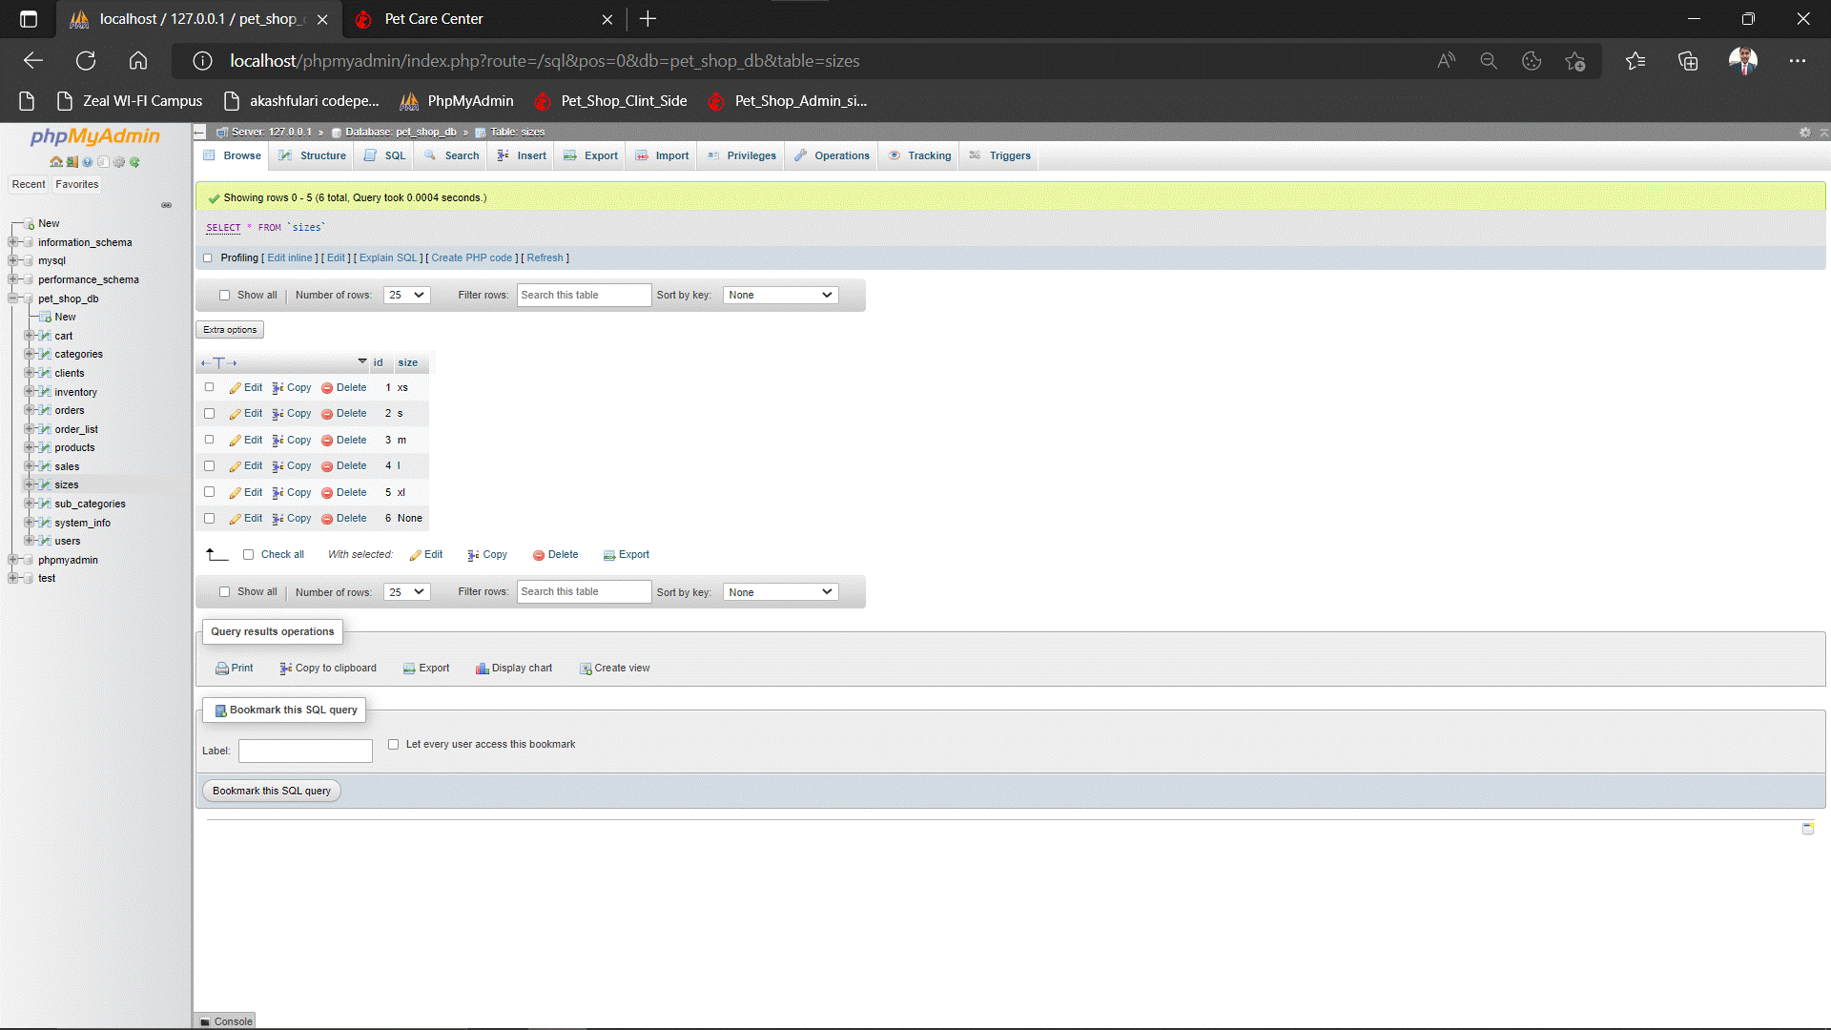

**Sub Category Table:**

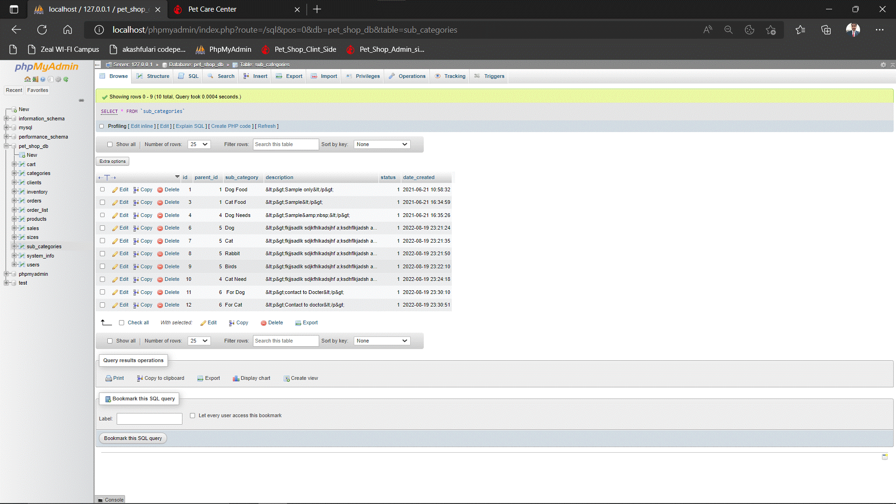

**System Info Table:**

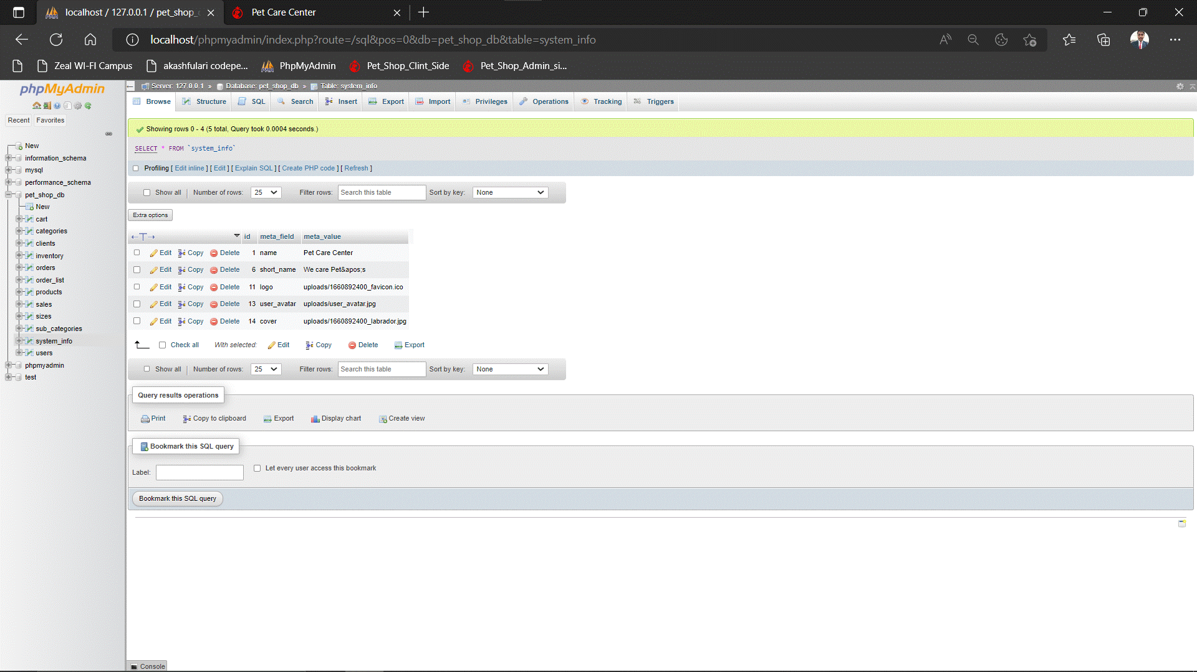

**User Table:**

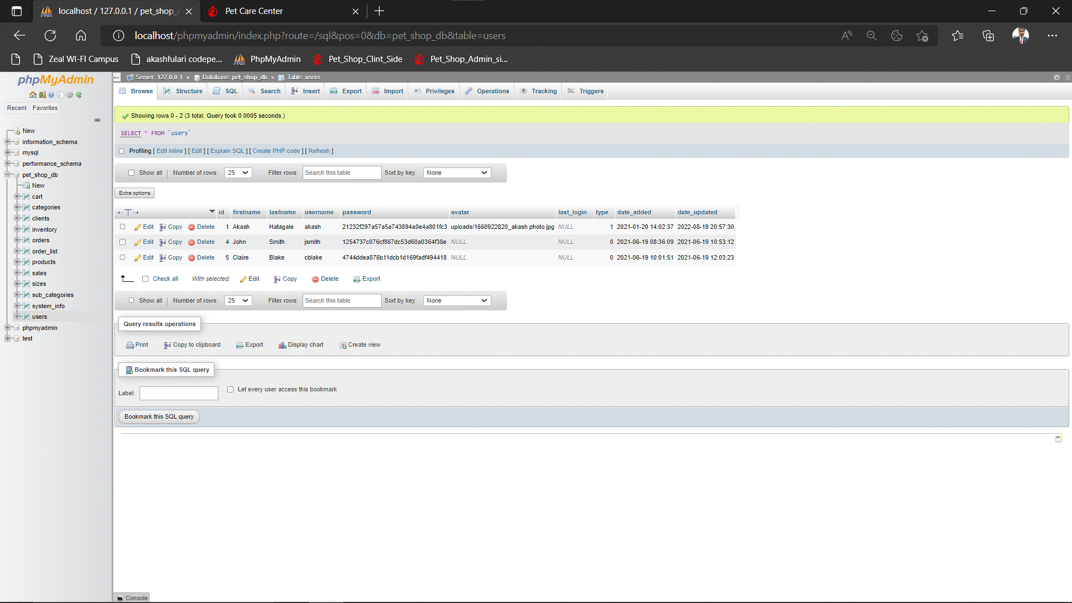

**CHAPTER 4:**

**CODING**

**4.1 Code Snippets: -**

* **Index.php: -**

<?php require_once('config.php'); ?>

<!DOCTYPE html>

<html lang="en">

<?php require_once('inc/header.php') ?>

<body>

<?php require_once('inc/topBarNav.php') ?>

<?php $page = isset($_GET['p']) ? $_GET['p'] : 'home'; ?>

<?php

if(!file_exists($page.".php") && !is_dir($page)){

include '404.html';

}else{

if(is_dir($page))

include $page.'/index.php';

else

include $page.'.php';

}

?>

<?php require_once('inc/footer.php') ?>

<div class="modal fade" id="confirm_modal" role='dialog'>

<div class="modal-dialog modal-md modal-dialog-centered" role="document">

<div class="modal-content">

<div class="modal-header">

<h5 class="modal-title">Confirmation</h5>

</div>

<div class="modal-body">

<div id="delete_content"></div>

</div>

<div class="modal-footer">

<button type="button" class="btn btn-primary" id='confirm' onclick="">Continue</button>

<button type="button" class="btn btn-secondary" data-dismiss="modal">Close</button>

</div>

</div>

</div>

</div>

<div class="modal fade" id="uni_modal" role='dialog'>

<div class="modal-dialog rounded-0 modal-md modal-dialog-centered" role="document">

<div class="modal-content rounded-0">

<div class="modal-header">

<h5 class="modal-title"></h5>

</div>

<div class="modal-body">

</div>

<div class="modal-footer">

<button type="button" class="btn btn-primary" id='submit' onclick="$('#uni_modal form').submit()">Save</button>

<button type="button" class="btn btn-secondary" data-dismiss="modal">Cancel</button>

</div>

</div>

</div>

</div>

<div class="modal fade" id="uni_modal_right" role='dialog'>

<div class="modal-dialog rounded-0 modal-full-height modal-md" role="document">

<div class="modal-content rounded-0">

<div class="modal-header">

<h5 class="modal-title"></h5>

<button type="button" class="close" data-dismiss="modal" aria-label="Close">

<span class="fa fa-arrow-right"></span>

</button>

</div>

<div class="modal-body">

</div>

</div>

</div>

</div>

<div class="modal fade" id="viewer_modal" role='dialog'>

<div class="modal-dialog modal-md" role="document">

<div class="modal-content">

<button type="button" class="btn-close" data-dismiss="modal"><span class="fa fa-times"></span></button>

<img src="" alt="">

</div>

</div>

</div>

</body>

</html>

**2) LOGIN PAGE:**

<style>

#uni_modal .modal-content>.modal-footer,#uni_modal .modal-content>.modal-header{

display:none;

}

</style>

<div class="container-fluid">

<div class="row">

<h3 class="float-right">

<button type="button" class="close" data-dismiss="modal" aria-label="Close">

<span aria-hidden="true">&times;</span>

</button>

</h3>

<div class="col-lg-12">

<h3 class="text-center">Login</h3>

<hr>

<form action="" id="login-form">

<div class="form-group">

<label for="" class="control-label">Email</label>

<input type="email" class="form-control form" name="email" required>

</div>

<div class="form-group">

<label for="" class="control-label">Password</label>

<input type="password" class="form-control form" name="password" required>

</div>

<div class="form-group d-flex justify-content-between">

<a href="javascript:void()" id="create_account">Create Account</a>

<button class="btn btn-primary btn-flat">Login</button>

</div>

</form>

</div>

</div>

</div>

<script>

$(function(){

$('#create_account').click(function(){

uni_modal("","registration.php","mid-large")

})

$('#login-form').submit(function(e){

e.preventDefault();

start_loader()

if($('.err-msg').length > 0)

$('.err-msg').remove();

$.ajax({

url:_base_url_+"classes/Login.php?f=login_user",

method:"POST",

data:$(this).serialize(),

dataType:"json",

error:err=>{

console.log(err)

alert_toast("an error occured",'error')

end_loader()

},

success:function(resp){

if(typeof resp == 'object' && resp.status == 'success'){

alert_toast("Login Successfully",'success')

setTimeout(function(){

location.reload()

},2000)

}else if(resp.status == 'incorrect'){

var _err_el = $('<div>')

_err_el.addClass("alert alert-danger err-msg").text("Incorrect Credentials.")

$('#login-form').prepend(_err_el)

end_loader()

}else{

console.log(resp)

alert_toast("an error occured",'error')

end_loader()

}

}

})

})

})

</script>

**3) HOME PAGE:-**

<!-- Header-->

<header class="bg-dark py-5" id="main-header">

<div class="container px-4 px-lg-5 my-5">

<div class="text-center text-white">

<h1 class="display-4 fw-bolder">Your Pets Deserve The Best</h1>

<p class="lead fw-normal text-white-50 mb-0">Looking for your pet's needs? Shop Now!</p>

</div>

</div>

</header>

<!-- Section-->

<section class="py-5">

<div class="container px-4 px-lg-5 mt-5">

<div class="row gx-4 gx-lg-5 row-cols-md-3 row-cols-xl-4 justify-content-center">

<?php

$products = $conn->query("SELECT * FROM `products` where status = 1 order by rand() limit 8 ");

while($row = $products->fetch_assoc()):

$upload_path = base_app.'/uploads/product_'.$row['id'];

$img = "";

if(is_dir($upload_path)){

$fileO = scandir($upload_path);

if(isset($fileO[2]))

$img = "uploads/product_".$row['id']."/".$fileO[2];

// var_dump($fileO);

}

$inventory = $conn->query("SELECT * FROM inventory where product_id = ".$row['id']);

$inv = array();

while($ir = $inventory->fetch_assoc()){

$inv[$ir['size']] = number_format($ir['price']);

}

?>

<div class="col mb-5">

<div class="card h-100 product-item">

<!-- Product image-->

<img class="card-img-top w-100" src="<?php echo validate_image($img) ?>" alt="..." />

<!-- Product details-->

<div class="card-body p-4">

<div class="text-center">

<!-- Product name-->

<h5 class="fw-bolder"><?php echo $row['product_name'] ?></h5>

<!-- Product price-->

<?php foreach($inv as $k=> $v): ?>

<span><b><?php echo $k ?>: </b><?php echo $v ?></span>

<?php endforeach; ?>

</div>

</div>

<!-- Product actions-->

<div class="card-footer p-4 pt-0 border-top-0 bg-transparent">

<div class="text-center">

<a class="btn btn-flat btn-primary " href=".?p=view_product&id=<?php echo md5($row['id']) ?>">View</a>

</div>

</div>

</div>

</div>

<?php endwhile; ?>

</div>

</div>

</section>

**4) INVENTORY PAGE: -**

<?php

if(isset($_GET['id']) && $_GET['id'] > 0){

$qry = $conn->query("SELECT * from `inventory` where id = '{$_GET['id']}' ");

if($qry->num_rows > 0){

foreach($qry->fetch_assoc() as $k => $v){

$$k=$v;

}

}

}

?>

<div class="card card-outline card-info">

<div class="card-header">

<h3 class="card-title"><?php echo isset($id) ? "Update ": "Create New " ?> Inventory</h3>

</div>

<div class="card-body">

<form action="" id="inventory-form">

<input type="hidden" name ="id" value="<?php echo isset($id) ? $id : '' ?>">

<div class="form-group">

<label for="product_id" class="control-label">Product</label>

<select name="product_id" id="product_id" class="custom-select select2" required>

<option value=""></option>

<?php

$qry = $conn->query("SELECT * FROM `products` order by product_name asc");

while($row= $qry->fetch_assoc()):

?>

<option value="<?php echo $row['id'] ?>" <?php echo isset($product_id) && $product_id == $row['id'] ? 'selected' : '' ?>><?php echo $row['product_name'] ?></option>

<?php endwhile; ?>

</select>

</div>

<div class="form-group">

<label for="size" class="control-label">Size</label>

<select name="size" id="size" class="custom-select select2" required>

<option value=""></option>

<?php

$qry = $conn->query("SELECT * FROM `sizes`");

while($row= $qry->fetch_assoc()):

?>

<option <?php echo isset($size) && $size == strtoupper($row['size']) ? 'selected' : '' ?>><?php echo strtoupper($row['size']) ?></option>

<?php endwhile; ?>

</select>

</div>

<div class="form-group">

<label for="unit" class="control-label">Unit</label>

<input type="text" class="form-control form" required name="unit" value="<?php echo isset($unit) ? $unit : '' ?>">

</div>

<div class="form-group">

<label for="quantity" class="control-label">Beginning Quanatity</label>

<input type="number" class="form-control form" required name="quantity" value="<?php echo isset($quantity) ? $quantity : '' ?>">

</div>

<div class="form-group">

<label for="price" class="control-label">Price</label>

<input type="number" step="any" class="form-control form" required name="price" value="<?php echo isset($price) ? $price : '' ?>">

</div>

</form>

</div>

<div class="card-footer">

<button class="btn btn-flat btn-primary" form="inventory-form">Save</button>

<a class="btn btn-flat btn-default" href="?page=inventory">Cancel</a>

</div>

</div>

<script>

function displayImg(input,_this) {

console.log(input.files)

var fnames = []

Object.keys(input.files).map(k=>{

fnames.push(input.files[k].name)

})

_this.siblings('.custom-file-label').html(JSON.stringify(fnames))

}

$(document).ready(function(){

$('.select2').select2({placeholder:"Please Select here",width:"relative"})

$('#inventory-form').submit(function(e){

e.preventDefault();

var _this = $(this)

$('.err-msg').remove();

start_loader();

$.ajax({

url:_base_url_+"classes/Master.php?f=save_inventory",

data: new FormData($(this)[0]),

cache: false,

contentType: false,

processData: false,

method: 'POST',

type: 'POST',

dataType: 'json',

error:err=>{

console.log(err)

alert_toast("An error occured",'error');

end_loader();

},

success:function(resp){

if(typeof resp =='object' && resp.status == 'success'){

location.href = "./?page=inventory";

}else if(resp.status == 'failed' && !!resp.msg){

var el = $('<div>')

el.addClass("alert alert-danger err-msg").text(resp.msg)

_this.prepend(el)

el.show('slow')

$("html, body").animate({ scrollTop: _this.closest('.card').offset().top }, "fast");

end_loader()

}else{

alert_toast("An error occured",'error');

end_loader();

console.log(resp)

}

}

})

})

$('.summernote').summernote({

height: 200,

toolbar: [

[ 'style', [ 'style' ] ],

[ 'font', [ 'bold', 'italic', 'underline', 'strikethrough', 'superscript', 'subscript', 'clear'] ],

[ 'fontname', [ 'fontname' ] ],

[ 'fontsize', [ 'fontsize' ] ],

[ 'color', [ 'color' ] ],

[ 'para', [ 'ol', 'ul', 'paragraph', 'height' ] ],

[ 'table', [ 'table' ] ],

[ 'view', [ 'undo', 'redo', 'fullscreen', 'codeview', 'help' ] ]

]

})

})

</script>

**CHAPTER 5:**

**LIMITATIONS OF PROPOSED SYSTEM.**

5.1 Limitations Of Proposed System: -

1) As there is a requirement of the internet to use this system

2) There is lack of feel or touch of products will be purchasing them online.

3) The cost of the creation and building of this system may be very high.

4) Does not keep track of product.

5) It requires a reliable internet connection.

**CHAPTER6:**

**PROPOSED ENHANCEMENTS.**

**Enhancement:** The main objective of Pet Care WEB is to enhance and upgrade the existing system by increasing its efficiency and effectiveness. The website improves the working methods by replacing the existing manual system with the computer-based system.

**Automation:** The Pet Care website automates each and every activity of the manual system and increases its throughput. Thus the response time of the system is very less and it works very fast.

**Accuracy:** The Pet Care website provides the uses a quick response with very accurate information regarding the users etc. Any details or system in an accurate manner, as and when required.

**User-Friendly**: The Pet Care website has a very user-friendly interface. Thus the users will feel very easy to work on it.The software provides accuracy along with a pleasant interface. Make the present manual system more interactive, speedy and user friendly.

**Availability:** The transaction reports of the system can be retried as and when required. Thus, there is no delay in the availability of any information, whatever needed, can be captured very quickly and easily.

**Maintenance Cost**: Reduce the cost of maintenance**.**

**Security**: This is very important aspect of the design and should cover areas of hardware reliability, fall back procedures, physical security of data and provision for detection of fraud and abuse. System design involves first logical design and then physical construction of the system. The logical design describes the structure and characteristics of features, like the outputs, inputs, files, database and procedures. The physical construction, which follows the logical design, produces actual website and a working system.

**CHAPTER7:**

**CONCLUSION.**

The project Pet shop is completed, satisfying the required design pacifications. The system provides a user-friendly interface. The website is developed with modular approach. All modules in the system have been tested with valid data and invalid data and everything work successfully. Thus the system has fulfilled all the objectives identified and is able to replace the existing system. The constraints are met and overcome successfully. The system is designed as like it was decided in the design phase. This website has a user-friendly screen that enables the user to use without any inconvenience. This would help the corporation prepare and organize its schedules more efficiently on the basis of traffic demand. Besides, it would provide data on concessions given to various sections.

The development of this pet shop is great improvement over the manual system

which uses lots of manual work and paper. The computerization of the system

speeds up the process.

The pet care center is fast, efficient and reliable, avoid data redundancy

and inconsistency it contains all the functionality future described in objective

of the project.

**CHAPTER 8:**

**BIBLIOGRAPHY**

Book Reference:

1. Learning PHP, MySQL & JavaScript

Author Name: -Robin Nixon

1. WEB DEVELOPER FOR BEGINNERS

AUTHER: WILLIAM BATTLE

1. SQL For Beginners

Auther: Chuck Roe

1. WEB DESIGNING AND PUBLISHING

Auther: prof satis jain

1. JavaScript modern Web Developer

Auther: Alok Ranjan, Abhilasha Sinha, Ranjit Battwad

1. Full Stack Wbe Development

Auther: Riaz Ahmed

Web-site Reference:-

1. <https://www.w3schools.com/html/html_intro.asp>
2. <https://www.udemy.com/css/css_background.asp>
3. <https://www.w3schools.com/js/>
4. <https://getbootstrap.com/docs/5.0/getting-started/introduction/>
5. <https://www.w3schools.com/xml/ajax_intro.asp>
6. <https://www.apachefriends.org/>
7. <https://www.campcodes.com/projects/php/online-e-learning-system-in-php/>
8. <https://www.w3schools.com/jquery/>